**Administrative training workshop for non-teaching staff**

Annual administrative training program 2020-21, for the non-teaching staff was conducted on 8th October 2020, by Internal Quality Assurance Cell.The training program was conducted for all the newly appointed non-teaching staff of all the institutions of Shivaji Education Society. It was attended by almost all the non-teaching employees of the management.

The function was inaugurated by the Principal. At the training program the resource person Mr.Vishal Naik, B.E.in Computer Science, enlightened the participants with his profound knowledge in computer hardware and software training. Shri T.N.Harikantra compered the program. I.Q.A.C Coordinator Prof. J.K. Nayak proposed vote of thanks.

**Report on the Vigilance Week Workshop**

As per the directions of the Central vigilance commission and the directorate of NSS, Vigilance week was observed in our college from 27thOctober 2022 to2nd November 2020.The following measures were taken during the occasion:

1. On 27-10- 2020 integrity pledge was taken by the principal, NSS Co-Ordinator, all the teaching and non-teaching staff of the college.
2. Integrity pledge was displayed on the notice board.
3. Integrity pledge was shared with all the class groups of students, the staff group, with the present and the past students through WhatsApp.
4. Integrity pledge is uploaded on the college website.

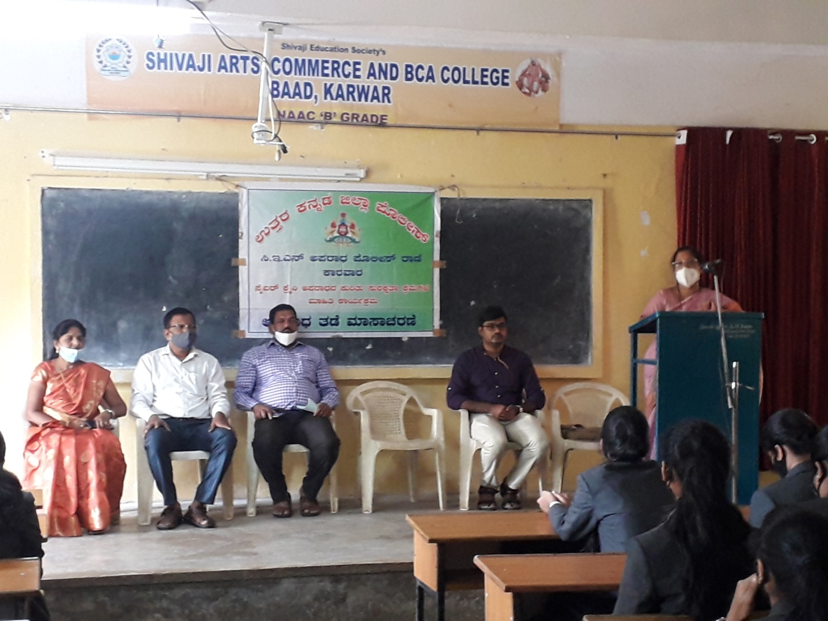

**Youth week program**

To commemorate the birth anniversary of Swami Vivekanand, the youth inspirer, a week long program from 12th January to 19 January 2020 was conducted in the college, to tap the hidden talents of the youths. The day is celebrated to cherish young people and their contribution for development. The students took part in all the events like elocution competition, essay competition, rangoli competition, quiz competition, drawing competition and singing competition. Under the guidance of teachers, the student leaders organized the Youth week program. The Principal addressed the students. Shri Uday Pawar, Principal, Shivaji Pre-University College, Chittakula, Sadashivgad, was the resource person who enlightened the students on the vision and mission of Swami Vivekananda. National Youth Day reminds us that we must always value the young energy of the country because they will make the future. The ladies representative, Teja Pednekar compered the program. General Secretary, Sourav Bhovi proposed vote of thanks.

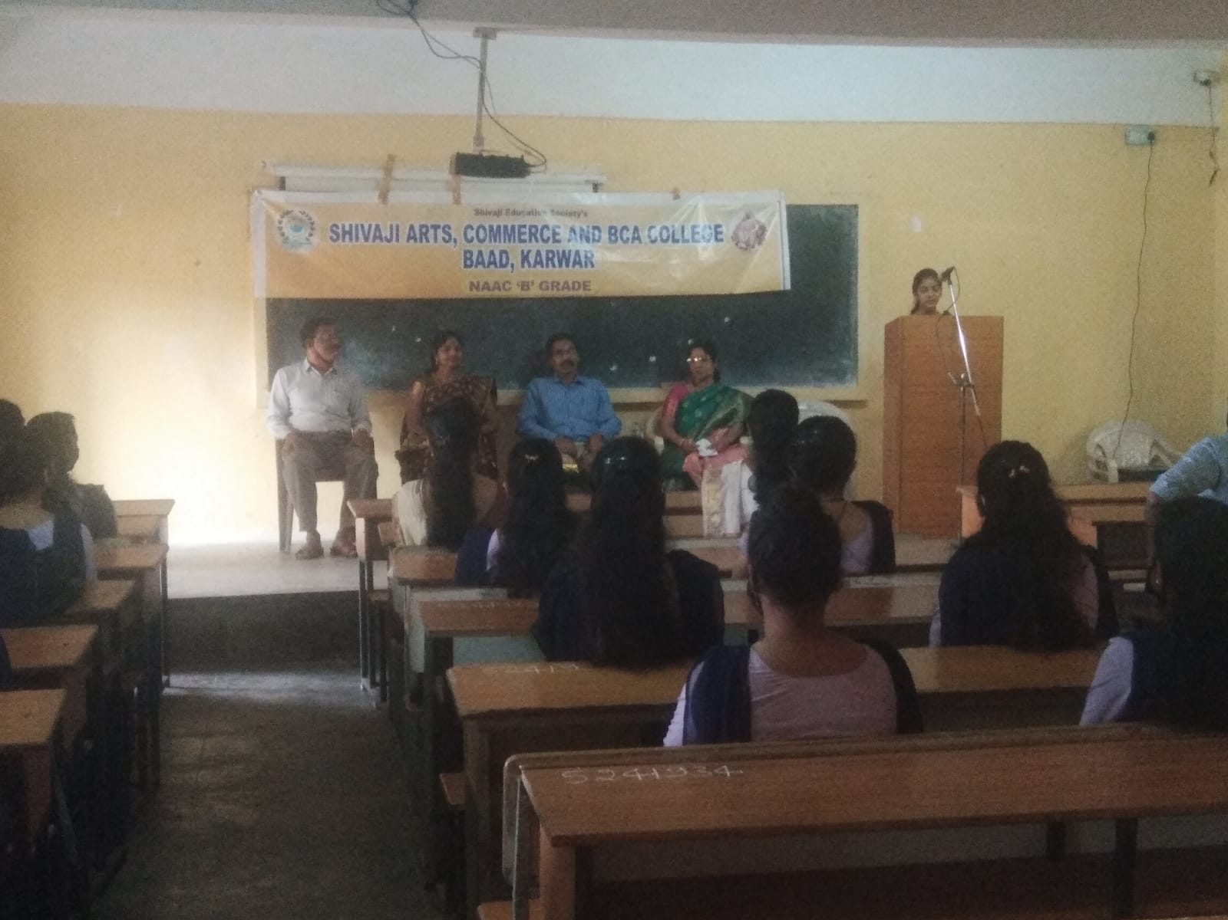

**Report on the Legal Awareness Workshop**

Shivaji Arts and Commerce College, in association with State and District Legal Service Authority, Karwar and Bar association of Karwar, jointly organised legal awareness workshop on 11-9-2020.

The chief guest of the occasion Shri.C.Rajashekhar,the District & Sessions Judge, speaking on the occasion, advised the audience to enjoy their rights, but at the same time respect the rights of others and reminded them to obey the law.

The other guest of the occasion Shri.N.Santoshkumar Shetty,Civil Judge, Sr. Division, informed that law and justice are there to protect people. He also told that there is a special provision for free legal service to people, who earn less than rupees three lakhs per year.Shri Anirudh Haldipur,President of Bar association of Karwar, graced the occasion.

Dr.Anuradha Naik, Principal, delivered the welcome address. Prof.Nausheen Mulla compered the program. Miss Jasmin and group sang the invocation song. Mr. Padmaraj, of District Legal Service Authority, Karwar, proposed vote of thanks. Students, teaching and non-teaching staff were present.

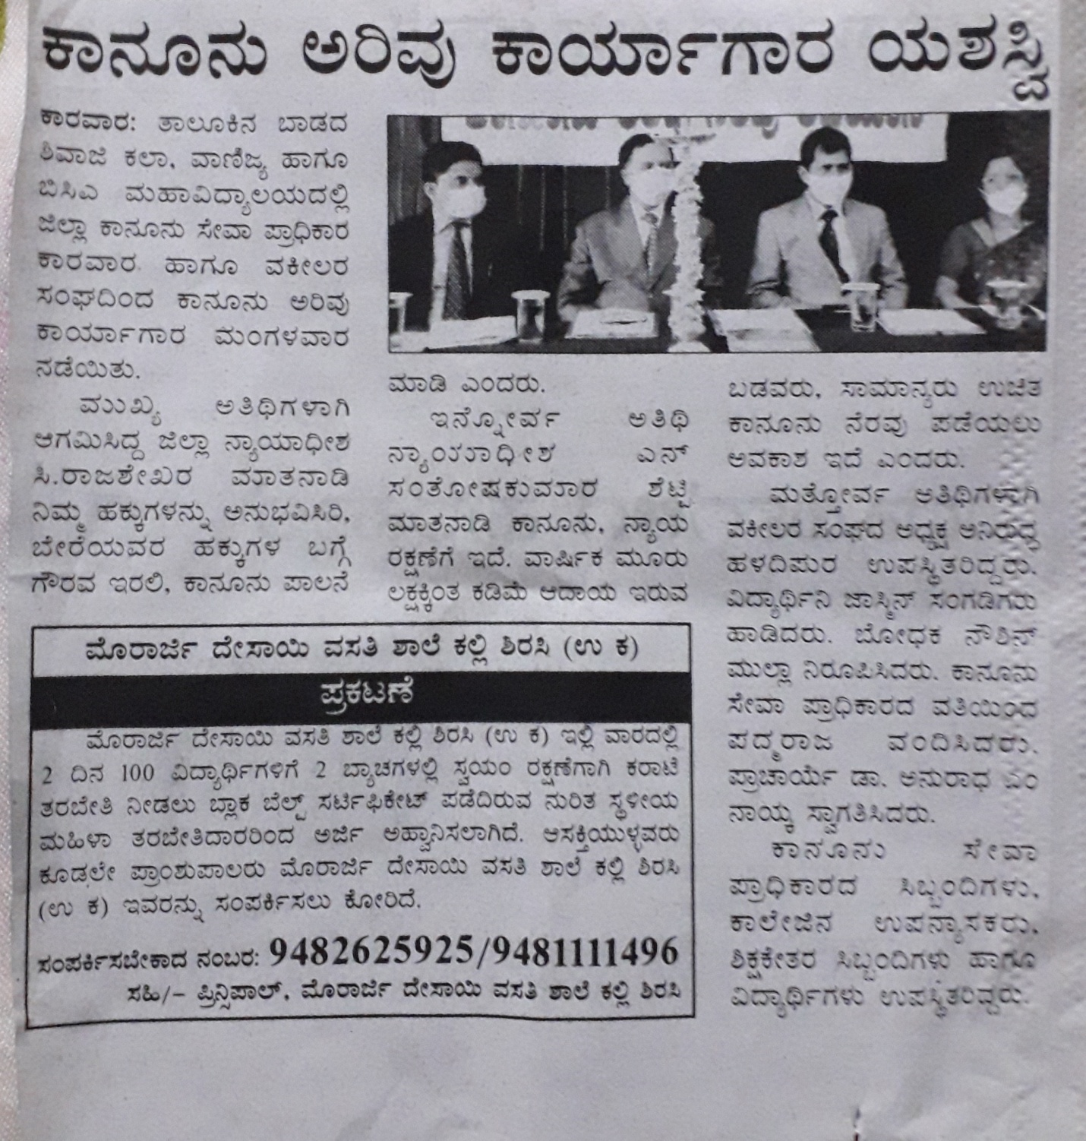

**Road safety Awareness week closing function**

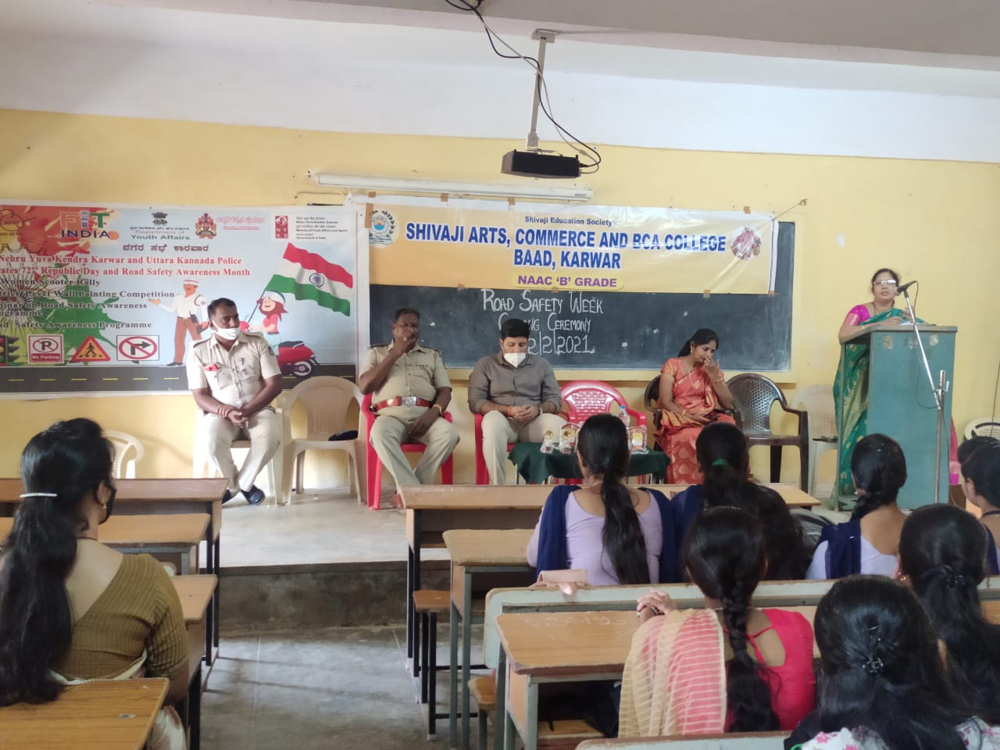

In collaboration with Police department and Nehru yuva Kendra, road safety awareness program was conducted to create an awareness, to follow the traffic rules to avoid the accidents. Mr. Disouza, PSI, Karwar briefed road safety rules. Shri Yashwant Yadav of Nehru Yuva Kendra, Karwar, interacted with the students. On the occasion the prizes were distributed to winners of essay competition.

Dr.Anuradha Naik, Principal, delivered the welcome address. Miss Teja compered the compered the program.

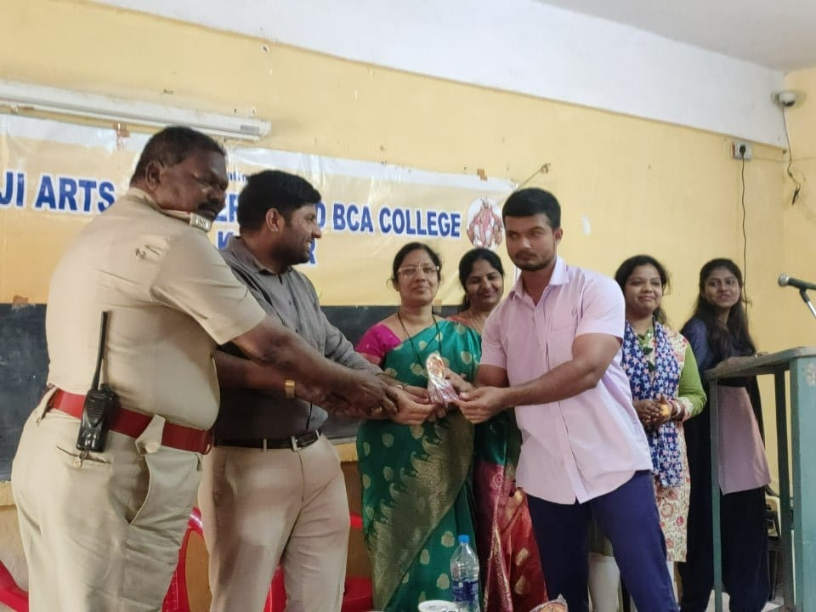

**Workshop on Safety Awareness for Girls**

Personal safety has become an issue of importance for everyone. Women and girls experience different forms of sexual violence in public places. So to create an awareness among girls regarding this and to train them regarding how to tackle such situations, the ladies department in association with IQAC, arranged a workshop to create safety awareness among girls on 12th February 2021.

Miss Rashmi Naik, winner of two national awards and a black belt in karate, explained the primary importance of self defense for women to be able to protect themselves. She explained women can empower themselves only through confidence. She told confidence encourages health, teaches discipline and reduces dependency. She demonstrated how the girls can ensure their safety by learning karate and taught some easy steps to the girls to save themselves in case of danger.

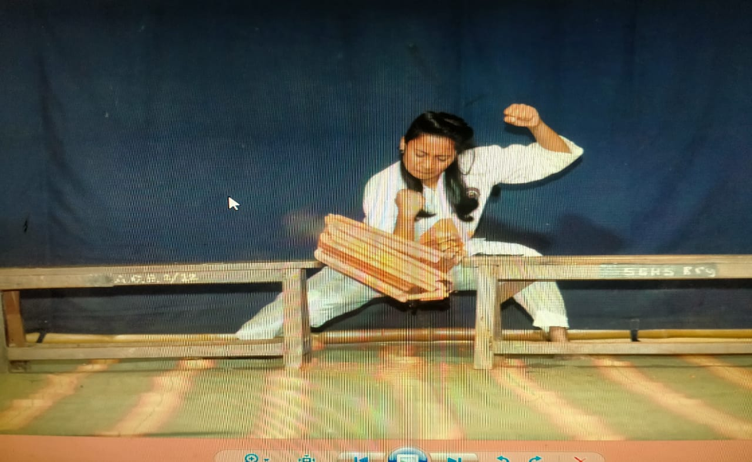.

**International Women’s Day 2021**

International women’s day is celebrated all over the world to recognise the historical, cultural and political achievements. It is also observed in support of taking action against gender inequality around the world. The majority of students and the teachers in the college are women. Our Principal is also a hard-working principled lady. Speaking on the occasion our principal Dr. Anuradha Naik expressed her deep faith in the women power potential and patience of women and expressed her deep faith in these qualities. The women of a college always outshine the other section of the society in every walk of life.

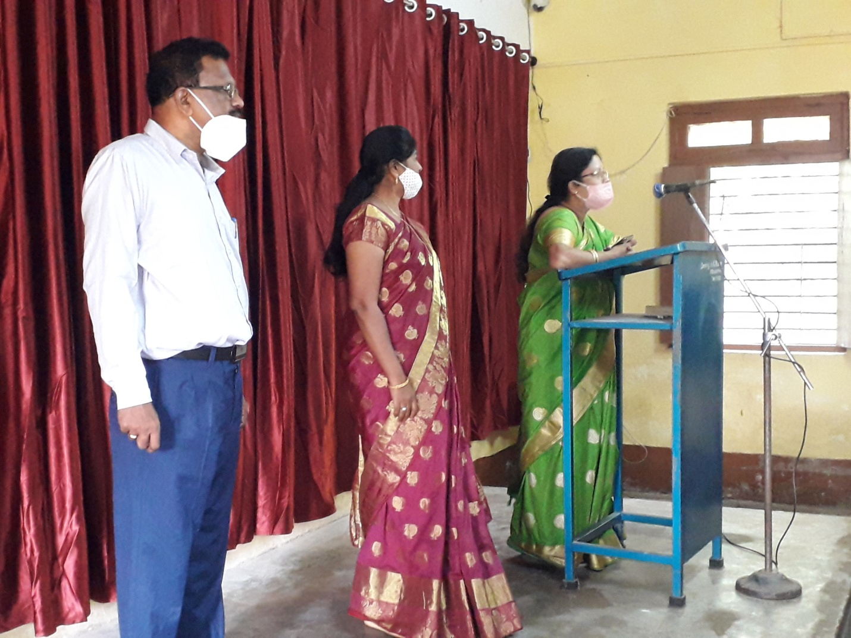

**Workshop on Green VillageClean Village**

On 12 March 2021, the college union in association with Kalpana Rashmi Dance Academy, CMC Karwar and Nehru Yuva Kendra, conducted ‘Green Village, CleanVillage’ program. To create environmental awareness and cleanliness awareness among the youths the program was organised jointly by all the organisations.

Speaking on the occasion Dr. Nithin Pikle, President, Karwar CMC, spoke about the measures taken by his organisation to keep the city clean. He explained to the gathering, how he and his team succeeded in keeping and enhancing the beauty of Karwar city. The second speaker of the occasion was Mr. P.D.Naik,a PDO, who explained to the audience how his unit re uses the garbage collected and converts it into a fertiliser by the well-planned project of the ZP. Shri Yashwant Yadav of Nehru Yuva Kendra, Karwar, interacted with the students.

A wall painting competition was held with a message of maintaining cleanliness. The winners were felicitated during the program.

Dr.Anuradha Naik, Principal, delivered the welcome address. Prof.Nausheen Mulla compered the program. Miss Jasmin and group sang the invocation song. Mr. Surya Prakash of Kalpana Rashmi dance Academy, Karwar, proposed vote of thanks. Students, teaching and non-teaching staff were present.

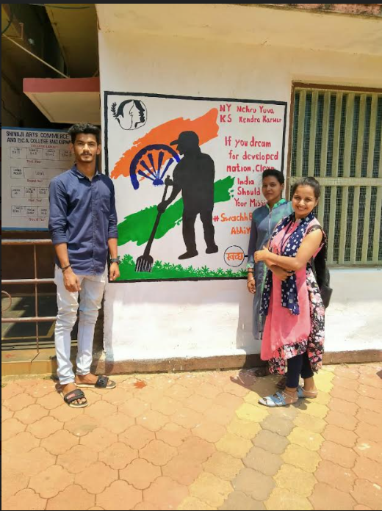 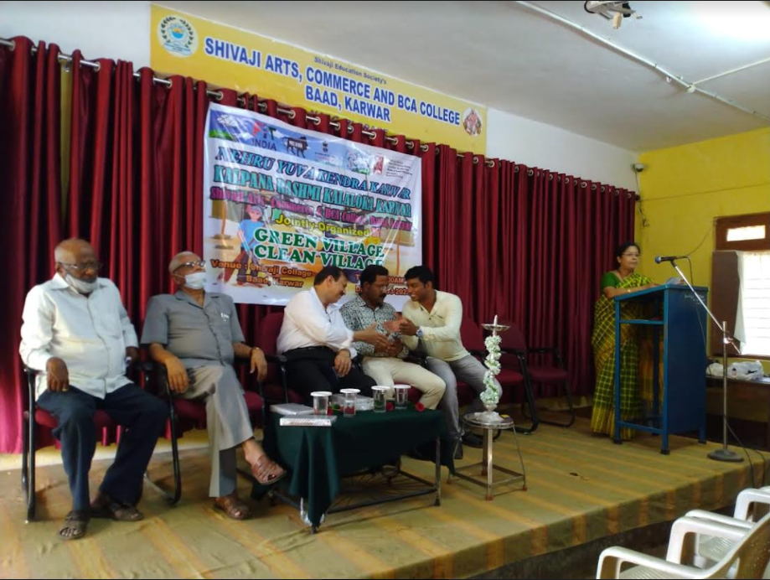

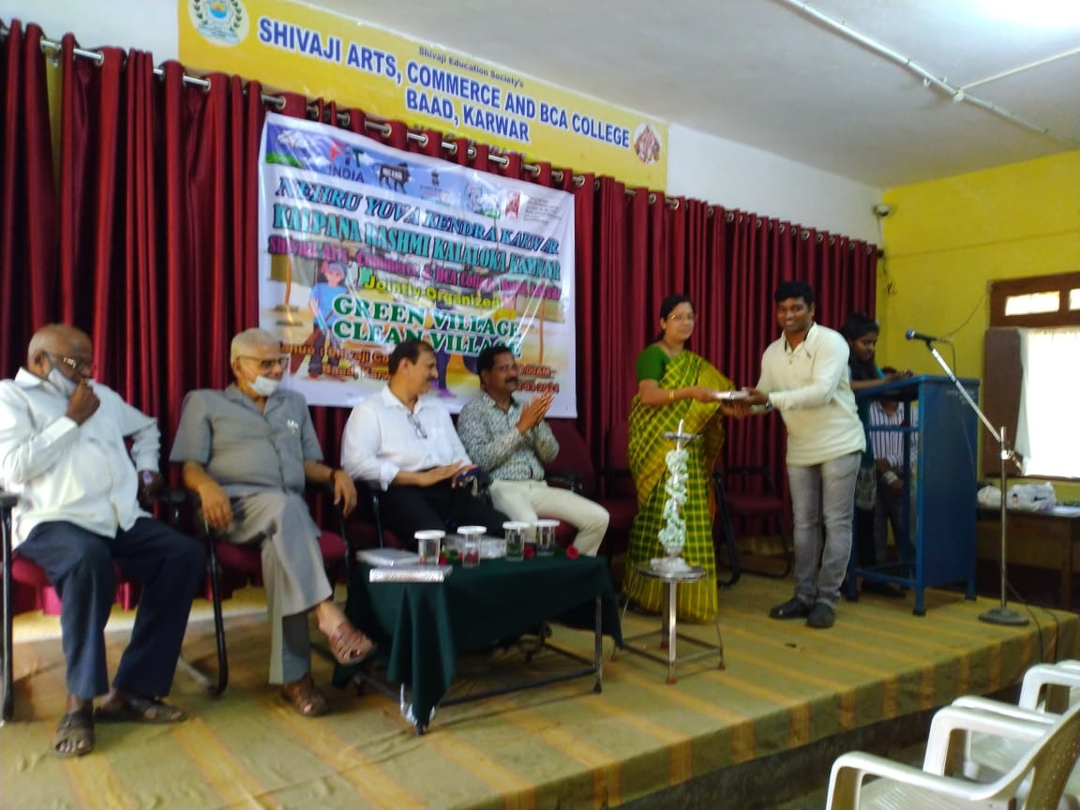

**State Level Webinar on Yoga**

The Department of Physical Education, in association with PG Department of studies in Yoga, Karnatak University, Dharwad, organised a state-level webinar on the occasion of international Yoga Day on 21st June 2021 on Google Meet platform. Dr Mahadeva Arer, Assistant Professor in PG Department of studies in Yoga, was the resource person. About 100 participants from all over the state witnessed the program. He explained about how yoga supports healing process and helps the person experience symptoms with more settings terminus and less distress.He explained how yoga improves strength, balance and flexibility. He also told yoga relieves backpain and eases off the symptoms of heart disease.

Dr. Anuradha Naik, Principal, delivered the welcome address. Professor Bhagyashri Naik compered the program. Shri T.N.Harikantra proposed vote of thanks.

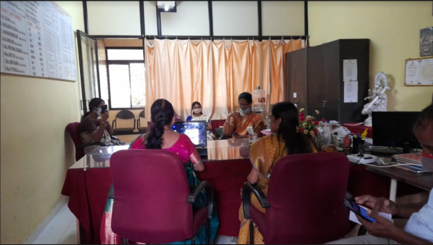 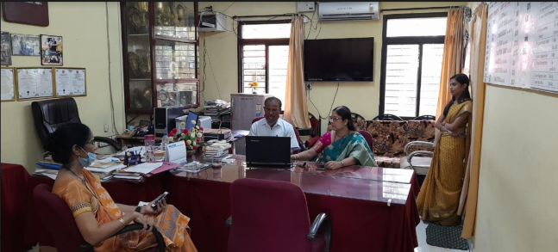

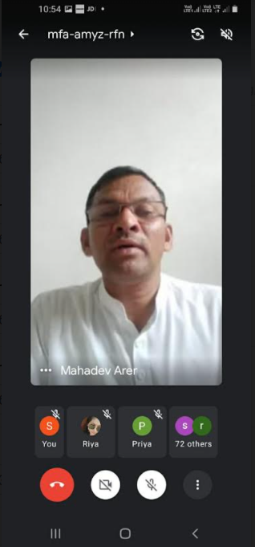 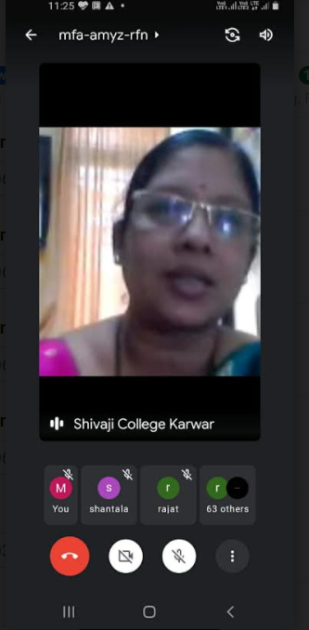

**State-Level Webinar on How to Prepare for Competitive Examinations**

Department of Political Science and the Placement Cell of Shivaji arts and commerce College jointly organised a state-level webinar in association with Vidhya Kasi career Academy Dharwad on how to prepare for competitive examinations on 22nd June 2021 at 11 AM on Google meet platform.

To enlighten the outgoing batch of final year students the young officers were invited to motivate them to appear and prepare themselves for competitive examinations. Shri Gaddeppa Gunjatagi, who secured second rank to the state in police sub-inspector exam and who is also honorary director of Vidya Kashi Career Academy was one of the resource persons. The second resource person was Akshata Vijapur, Deputy Range Forest Officer, Sirsi and the third resource person was Dr. Vaishali Warkar, Vidya Kashi career Academy, Dharwad.

All the three young achievers motivated and guided the outgoing final year students about the preparations to be made to get through the competitive exams successfully. They have also assured that they would render free training to our students on weekends through online platforms.

Dr.Anuradha Naik, Principal, delivered the welcome address. Prof. Bhagyashri Naik compered the program. Shri T.N.Harikantra proposed vote of thanks.

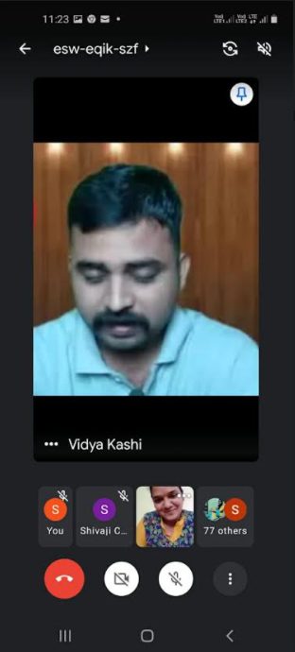 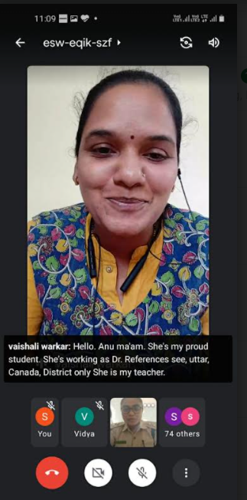 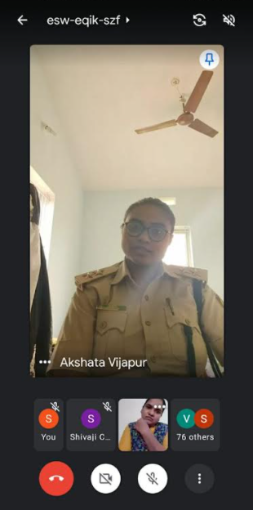

**Workshop on the Constitution Day program**

On 26-11- 2020, Constitution Day was celebrated in our college jointly by NSS and the Department of Political Science. An online program was conducted,wherein all the teaching and non-teaching staff joined directly and students joined the program through Cisco WebEx platform.Dr Vishwanath Naik,HOD, department of Political Science, Government Women’s College Karwar, was the resource person. He addressed the students on the aspect of personal liberty,the relevance of suspension of article 370 of the Constitution and the significance of the Constitution.

Dr. Anuradha Naik, Principal delivered the welcome address.Professor Bhagyashri Naik compered the program.Dr Bharati Dodamani, NSS Coordinator, proposed vote of thanks.Constitution pledge was taken by the staff, both teaching and non-teaching.

**State level Webinar on 'Catch The Rain'**

A State level webinar on 'Catch the rain' was conducted by the college NSS unit in association with State NSS cell, Karnatak University, Dharwad, on 14-8-2021, on the occasion of 75 years of India’s Independence.The chief guest of the function was Dr.B.M.Dalapati, Co-ordinator, State NSS cell, Karnatak university,Dharwad. Speaking on the occasion the chief guest spoke about the goals and functions of NSS. He guided the volunteers to cultivate spirit of social service in their personality. He congratulated the unit for conducting an extensive program like this, which is the need of the hourand also encouraged the staff to conduct some such functions in the future too.

Prof.Shivanand Bhat, Assistant Professor in Botany, GFGC,Karwar, was the resource person for the program. Speaking on the occasion the Professor spoke about the significance of water for survival,rain water harvesting, climatic conditions and sub-soil strata before monsoon etc.

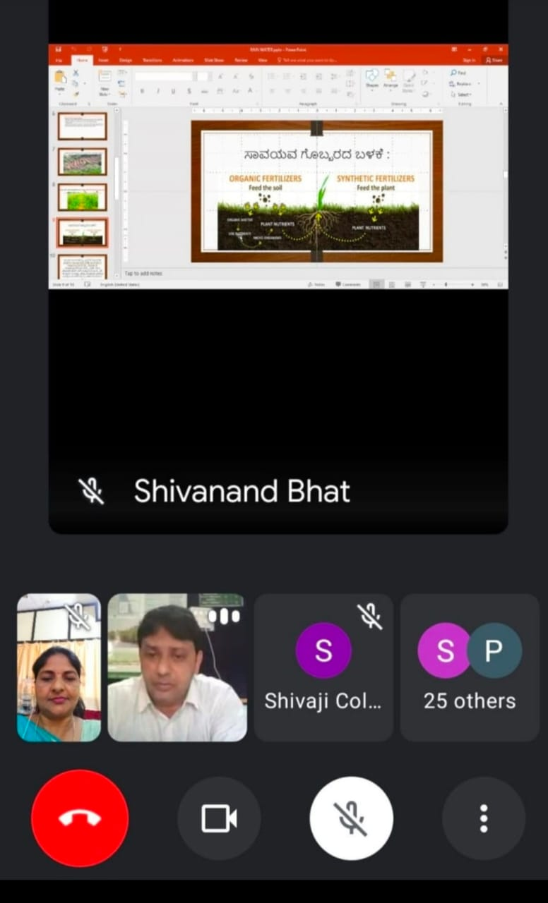

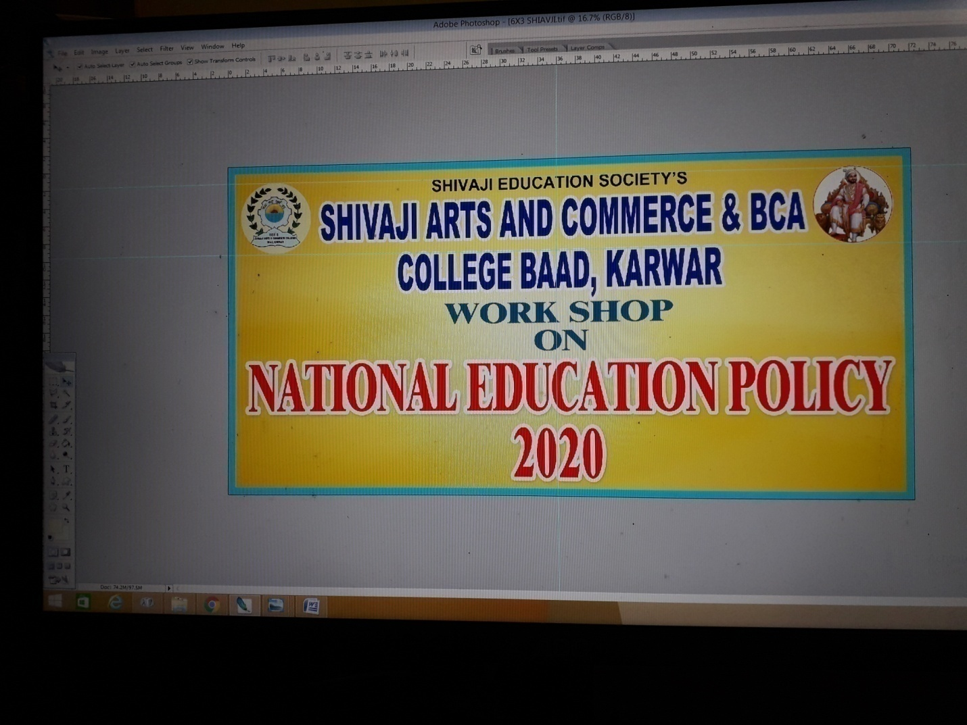

**Workshop on national education policy 2020 for teaching staff**

In response to the directions given by the Joint Director, Collegiate Education, Dharwad and with a view of bringing the objectives and goals of the National Education Policy 2020 to the notice of the stakeholders, a workshop on the national education policy 2020 was conducted in our college on 14 -9- 2021 at 11 AM for the faculty. The teaching and the non-teaching staff were present.Some of the firstyear students who had come to take admission on the day were also present .The principal briefed the staff and the students about the major attributes of NEP.All the staff members shared their views on NEP.

**Workshop on National Education Policy 2020 - 21**

As per the directions given by the Joint Director, Collegiate Education, Dharwad a workshop on the National Education Policy 2020 was conducted on 21-09-1021 at 11:30 AM for the parents and the fresher students, who have been admitted during the academic year 2021-22.Dr.Vishwanath Naik,Principal,Government Women’s College, Karwar, was the resource person on the occasion. He elaborated the purpose and the objectives of National Education Policy. Principal, Dr Anuradha Naik analysed the program structure of NEP and clearly explained about the CIE,Credit system, multiple entry and exit options of NEP. The parents and the students got their doubts clarified. ShriTaranath Harikantra Physical Director,hosted the program.All the teaching and non-teaching staff were present.

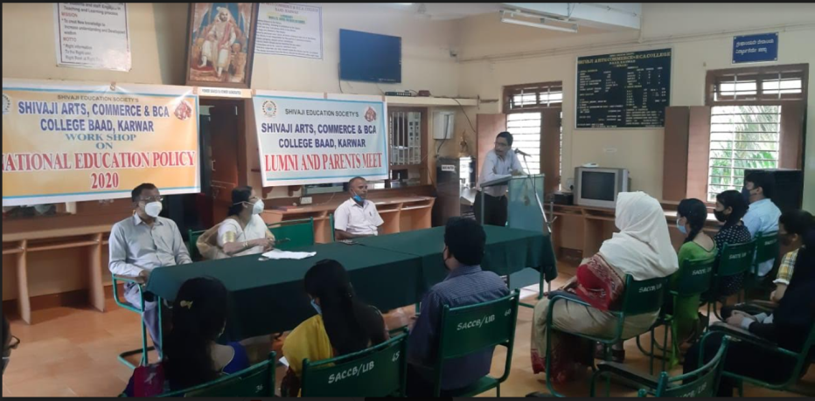

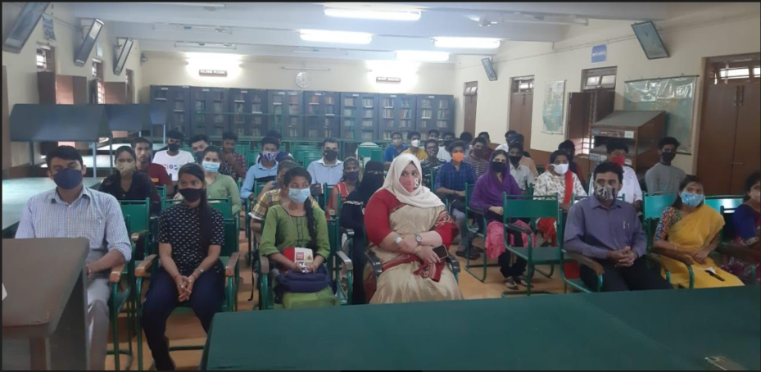

**2019-20**

**Report of the workshop on ‘Bad effects of tobacco’**

To create an awareness among the students about the bad effects of tobacco the union department of the college organised a state-level seminar on ‘Bad effects of tobacco’ in association with the Medical College, Karwar, on 23rd August, 2019.Dr Hemagiri, HOD ,Community medicine, Dr Girish, Dr. Malatesh and Dr. Prashant were the resource persons for the seminar .

Dr.A.M.Naik, principal gave the welcome speech. Thereafter, Dr Hemagiri delivered a lecture among the students and made them aware bad effects of tobacco through a PowerPoint presentation. After the lecture students took part in an interaction and cleared their misconception. The queries were answered by the speakers.

The function was attended by the lecturers, non-teaching staff and students. Prof.J.M.Rane,chairman, union department proposed vote of thanks. 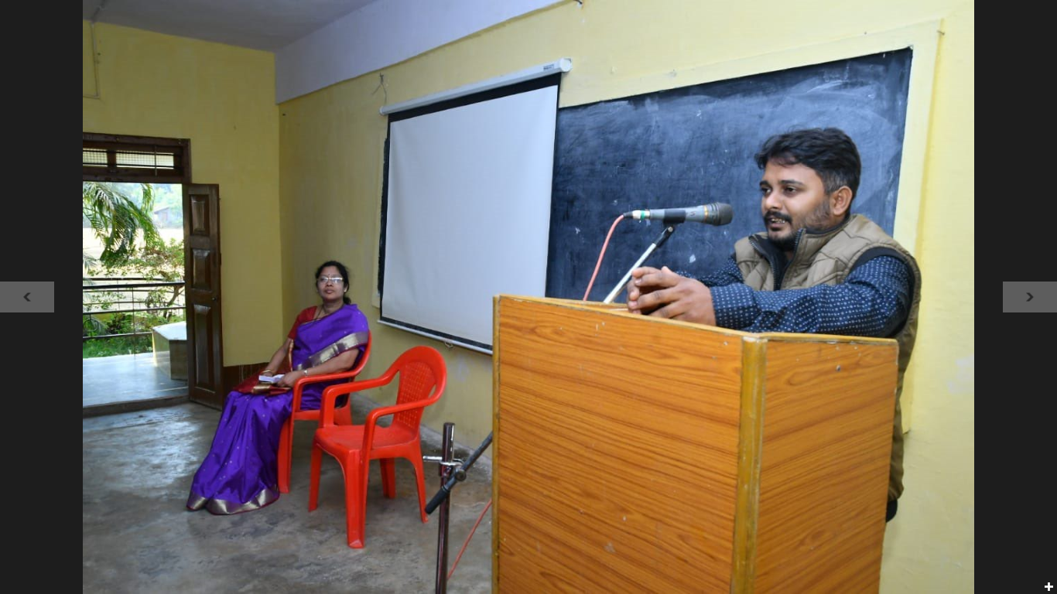

**Report of the workshop on ‘Interview skills ‘**

The placement cell of Shivaji Arts, Commerce and B.C.A College, organised a workshop on Interview skills on 9th September 2019, at 11 AM, in association with Karavali Institute of hotel management. Mr Maruti Rane of Premier hotel was the resource person on the occasion. As a man of the hotel industry nearly for20 years, he gave an informative speech. During the occasion, he informed the students what the management expects from the job aspirants. He said not only qualification is sufficient to get a job, but also there are many skills which are to be developed by the aspirants, who are in search of jobs. He said qualification, skill, confidence and soft skills help the graduates to secure placement in any industry.

The function was attended by the lecturers, students, non-teaching staff, management members. The principal welcomed the guests. Prof. Bhagyashri compered the function. Professor Harikantra presented vote of thanks.

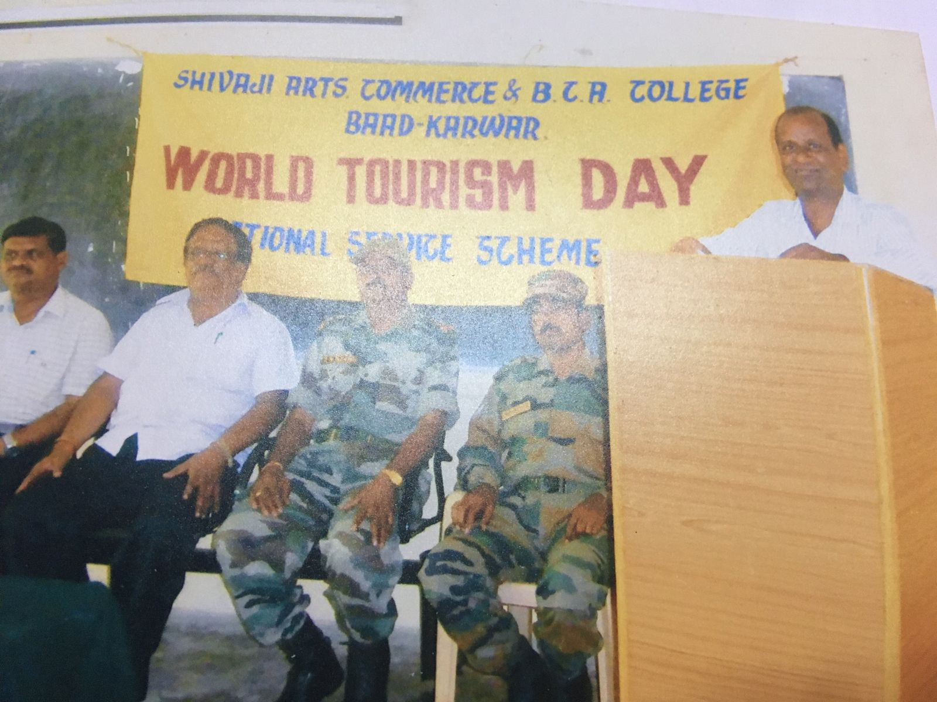

**Report of the workshop on ’Save water’**

To create an awareness among the students about the necessity of saving water for the survival of mankind, seminar on’ Save water’was organised in the college, in collaboration with forest department on 21st September, 2019 .Mr.Ganapati Nayak, a young range forest officer was the chief guest and the resource person .

Dr.A.M.Naik,principal gave the welcome speech. Thereafter,while inaugurating the rain water harvesting project, the officer congratulated the college for constructing the rain water harvesting plant. He stressed on saving water. Saving water is the need of the hour. He explained by making some behavioral change, we can reduce water wastage. He tried to convince the students through a PowerPoint presentation .After the lecture students took part in an interaction and cleared their misconception. The queries were answered by the speaker.

The function was attended by the lecturers, non-teaching staff and students. Prof.J.M.Rane, chairman, union department proposed vote of thanks.

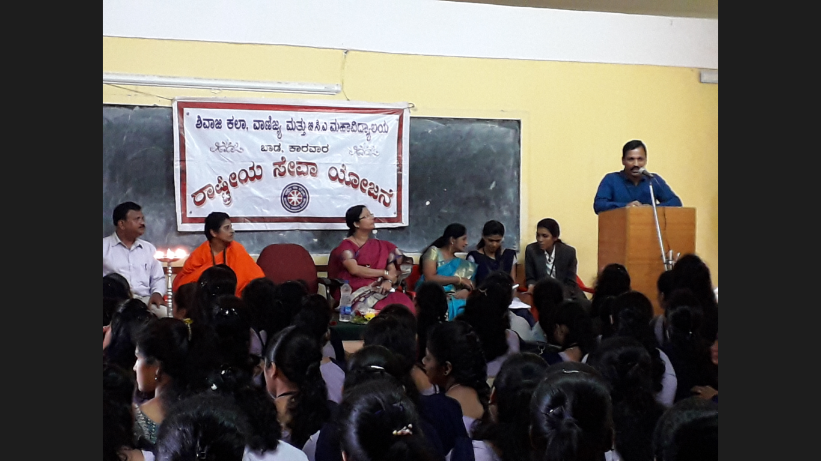

**Youth Festival 11th & 12th October 2019**

Shivaji Arts ,Commerce and BCA college hosted Karnatak university’s zonal level inter-collegiate youth festival on 11TH &12TH October 2019.Nearly 35 colleges and 600 students participated in the mega event. Nearly 600 students and hundred officials worked day and night to complete the huge task of assessing the efficient participants throughout the district.

The event was inaugurated by Mr.Satish Sail,Ex.MLA, Karwar. Mr.B.B.Rane, Retd. Deputy Commissioner & President Shivaji Education Society presided over the function. Inaugurating the event the dignitaries wished the function a huge success. The chief guest said he was lucky to spend time with efficient, young, enthusiastic participants. He wished them good luck and advised to honor fair play.

The event was concluded with the valedictory function on 12th October 2019.Addressing the gathering, Mr.Vidyadhar Savant, Vice-president. Shivaji Education Society,Baad,Karwar congratulated the prize winners and applauded the principal and her team for conducting the herculean task successfully. In the final medal tally SDM college, Honavar emerged as the champion team, followed by MES college, Sirsi. 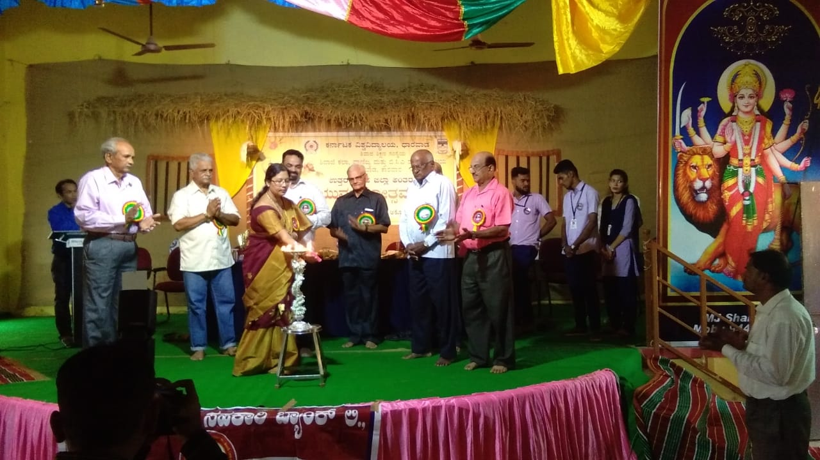

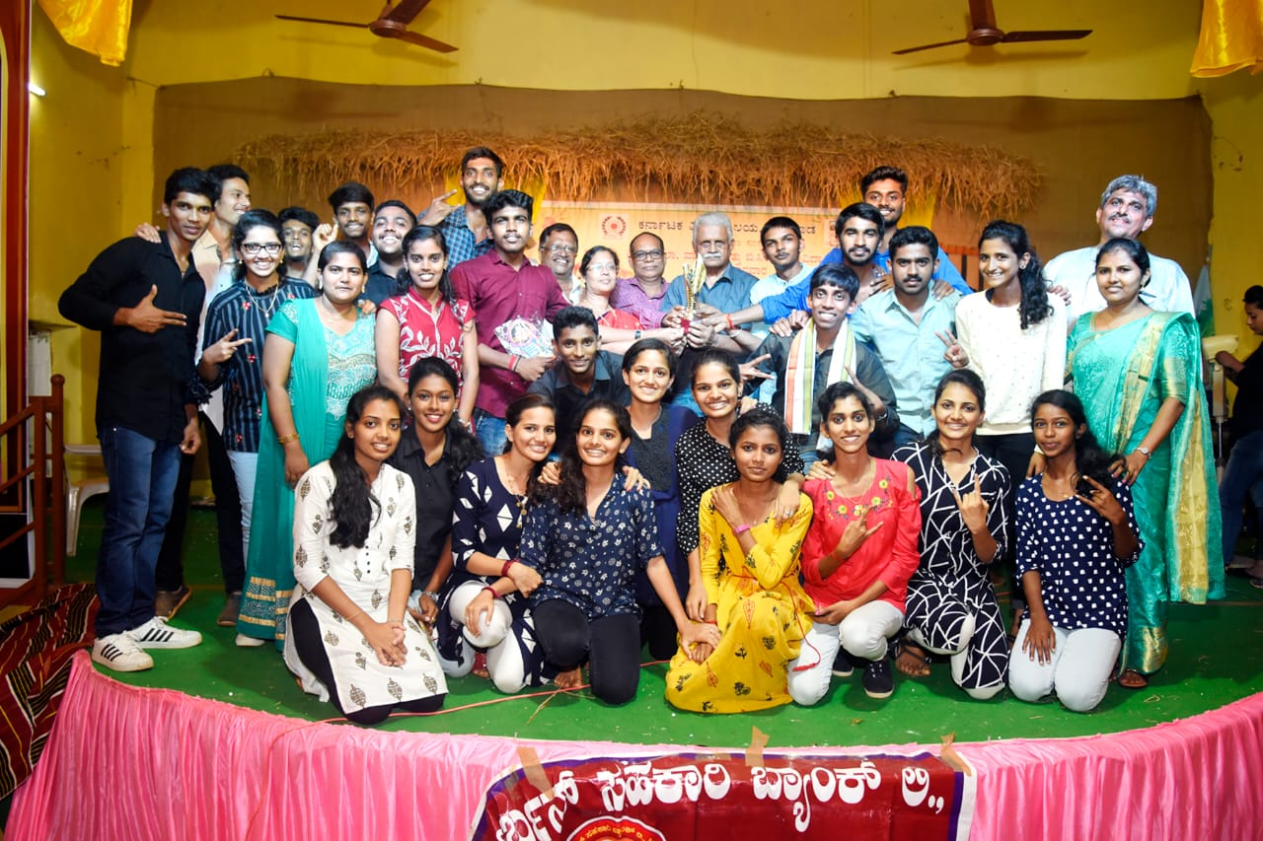

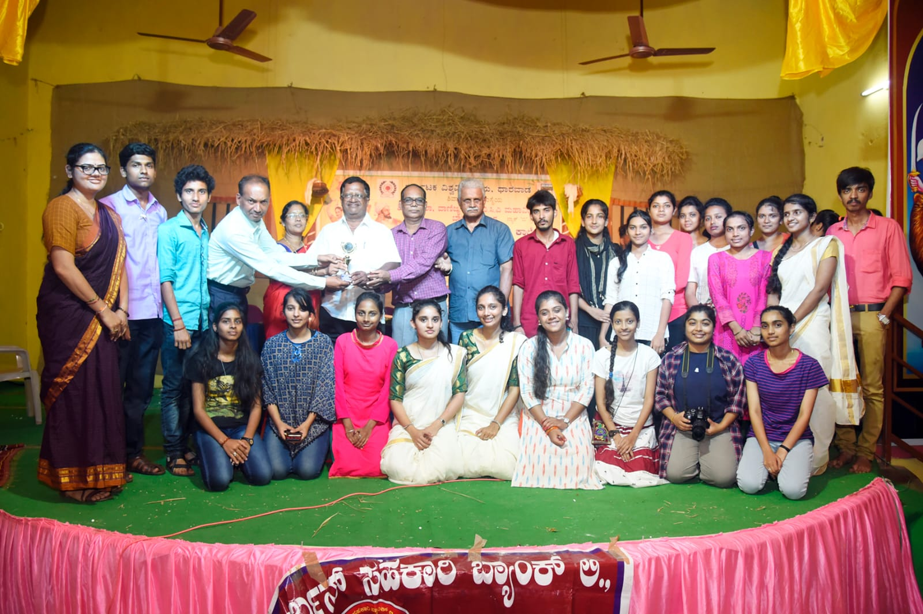

**Report on how to face competitive examinations**

The placement cell of Shivaji Arts, Commerce& BCA College and Gurudev Institute of career guidance, Dharwad jointly conducted the function on1st March, 2020. The chief guest of the occasion, while speaking about competitive exams, spoke about the methods of preparation for competitive exams. He guided the students to concentrate on the syllabus, asked them to refer previous year question papers .He said, hard work always fetches a result, how difficult the exams are. He advised the students to prepare effectively on daily basis, he suggested to fix weekly targets. Finally he told the students to be positive and confident, while preparing for any exams.

The function was attended by the lecturers, students, non-teaching staff. The principal welcomed the guests. Prof. Bhagyashri compered the function. Prof.T.N. Harikantra presented vote of thanks.

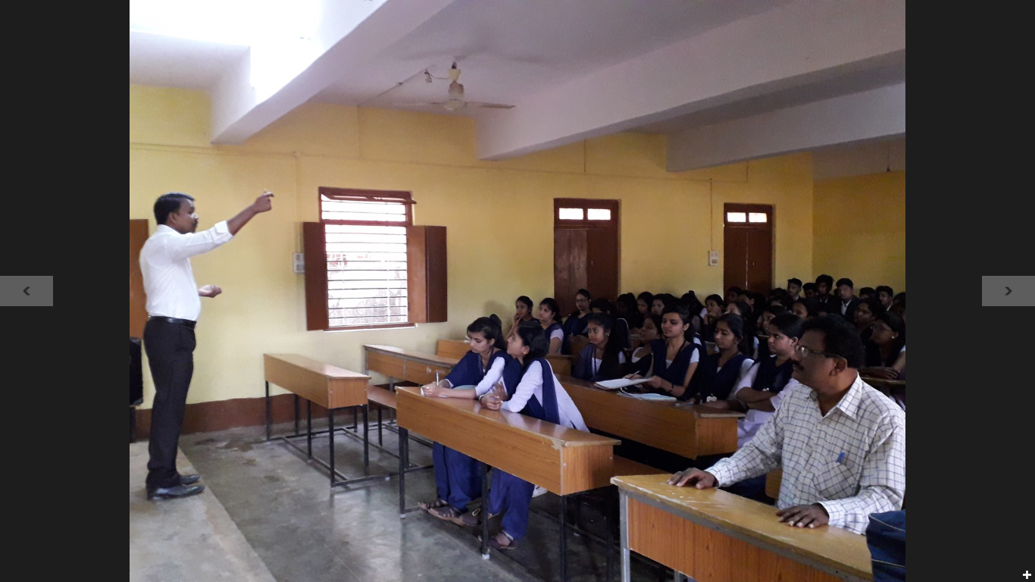

**Report on Legal awareness program**

Shivaji Arts and Commerce College, in association with District Legal Service Authority,Karwar and Bar association of Karwar, jointly organised legal awareness workshop on 21st January, 2020.

The chief guest of the occasion Shri.T.Govindayya, the District & Sessions Judge, speaking on the occasion, advised the audience to obey the law, but at the same time respect the rights of others.He informed that law and justice are there to protect people. He also told that there is a special provision for free legal service to people, who earn less than rupees three lakhs per year.

Dr.Anuradha Naik,Principal,delivered the welcome address.Prof.Ivy Disouza compered the program.Mr.Padmaraj, of District Legal Service Authority,Karwar, proposed vote of thanks.Students,teaching and non-teaching staff were present. 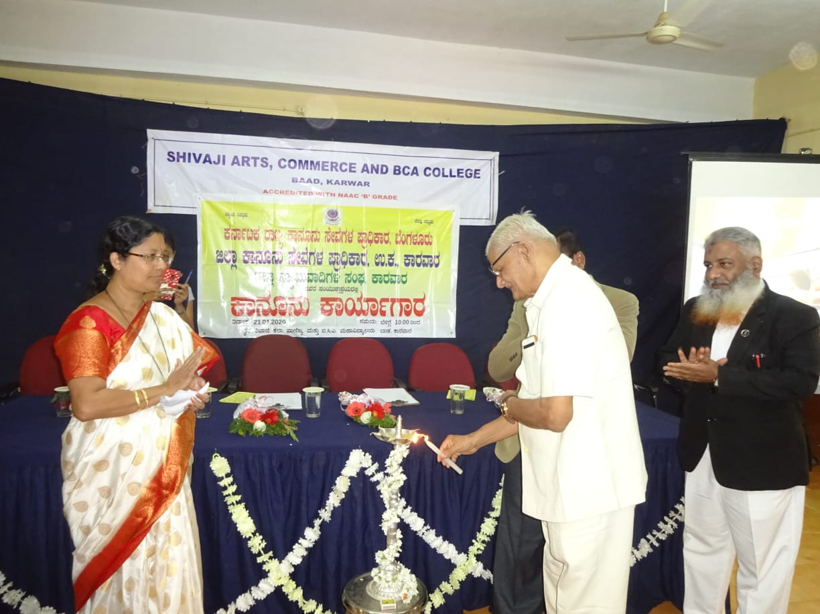

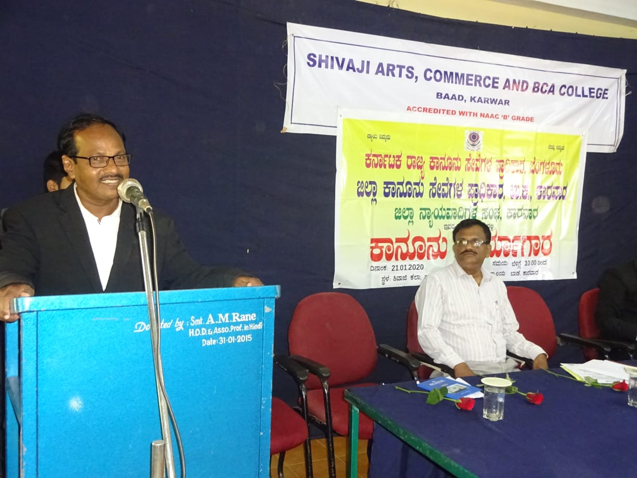

**Career guidance & Campus interview**

The career counseling and guidance cell arranged a workshop, to assist students to do better career choices. The workshop was conducted on 27 January, 2020 by the faculty of NIIT, Mangalore.

Dr.Anuradha Naik, Principal, delivered the welcome address. Thereafter the team leader, Miss Pavitra, faculty of NIIT, Mangalore, gave many tips regarding career guidance and placement. It was not only, a career counseling session, but also they conducted primary rounds of campus selection, for the final interview, which was to be conducted in Mangalore. Six of our students were shortlisted for the same. Prof.T.N. Harikantra, the placement officer presented vote of thanks.

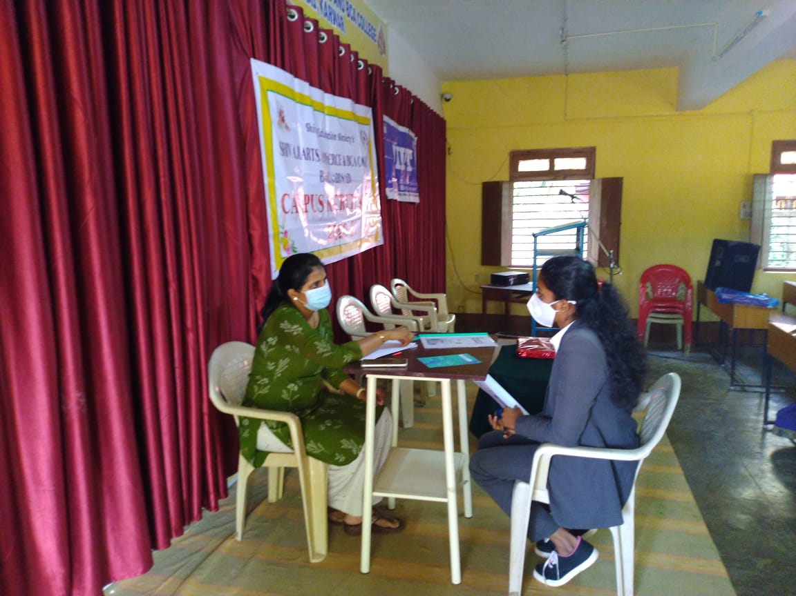

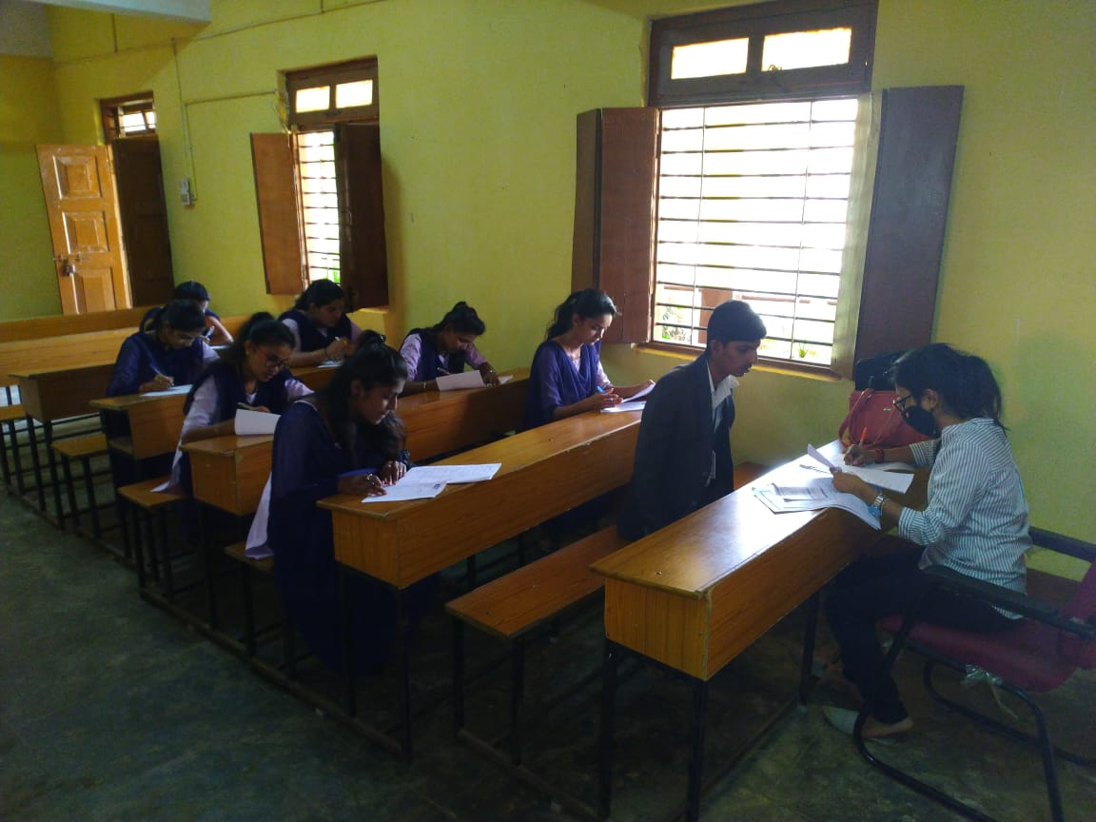

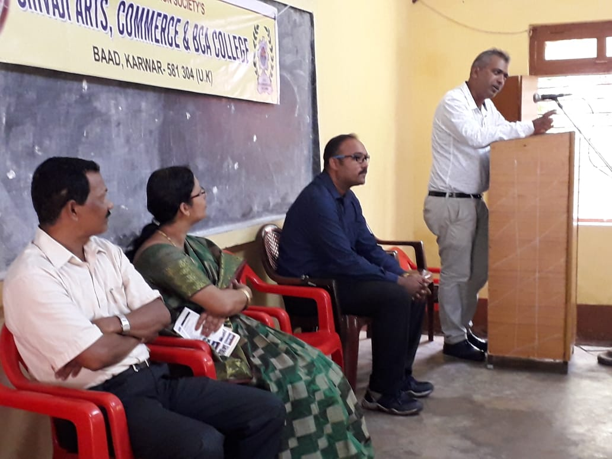

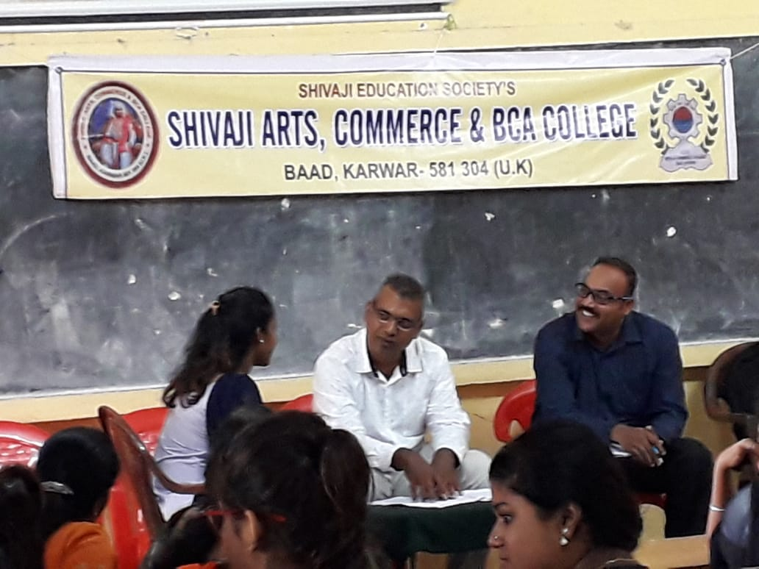

**AWARENESS PROGRAM ON HEALTH**

Ladies department of Shivaji college in collaboration with the Phoenix self help group, Karwar conducted an awareness program on health on 25th February, 2020. Dr. Aruna Rane, Gao, was the guest of honor.

Dr.A.M.Naik, Principal, Shivaji Arts and Commerce college, Baad, Karwar introduced and welcomed the guests to inaugurate the function. The doctor enlightened the girls how health is more important than academics. She convinced the students how they can balance their health and study together.

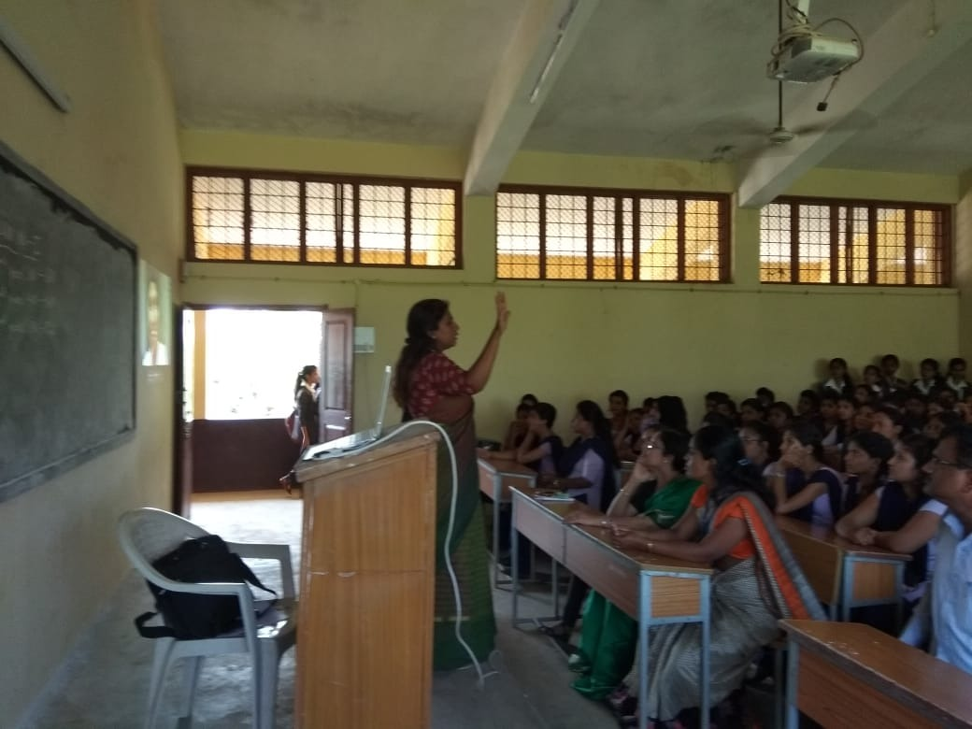

Safety awareness workshop

AWARENESS PROGRAM ON FIRST AID

In collaboration with 1) DEPARTMENT OF HEALTH

2) DEPARTMENT OF ROAD TRAFFIC

3) DEPARTMENT OF FIRE BRIGADE

Shivaji Arts and Commerce college in collaboration with the district administration conducted an awareness program on February 28, 2020. Dr.Nagesh Hubballi,Shri Nandish Harikantra , Smt.Padma Devali and Shri.G.M.Nadaf were the guests of honor. Dr.A.M.Naik, Principal, Shivaji Arts and Commerce college,Baad,Karwar introduced and welcomed the guests to inaugurate the function.

Addressing the students Dr.Nagesh Hubballi stressed on the importance of physical well being . He gave lecture on first aid.

Speaking on the occasion Smt.Padma Devali, PSI Karwar enlightened the students about traffic rules.she informed how traffic rules help to avoid accidents and save the valuable life.

Shri Nandish Harikantra of fire brigade department gave valuable suggestions regarding how life can be saved in the face of fire threat. Shri.G.M.Nadaf spoke about dangers of eating tobacco.

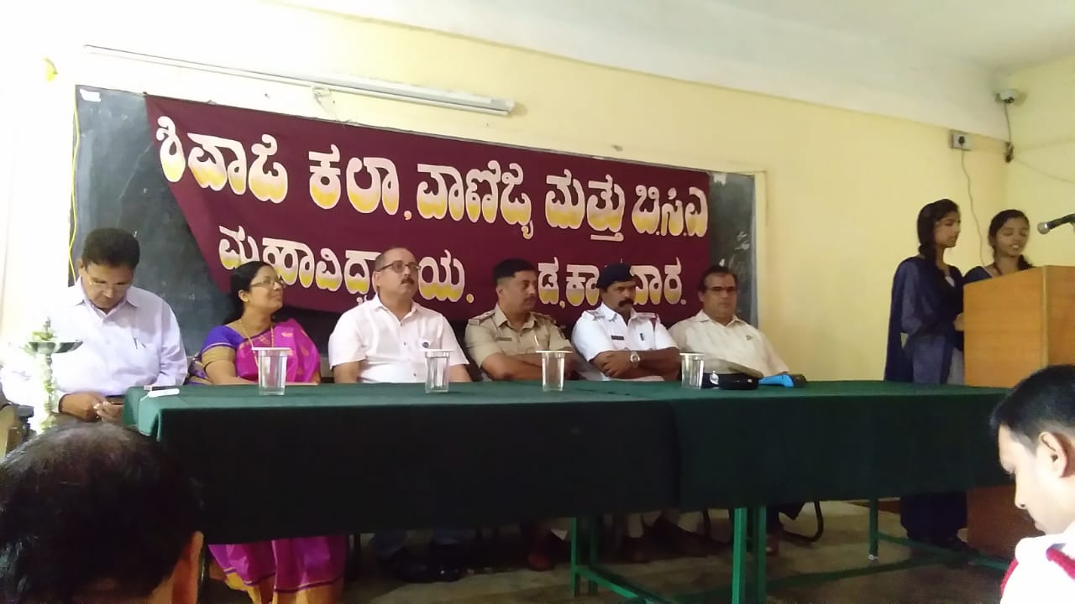

2018-19.

**Seminar on Transformation program**

To motivate the young minds of the youths, the IQAC has arranged a motivational seminar in collaboration with World Youth Change Makers, Karwar branch.The transformation program was conducted on 7th July 2018.

*Principal* A.G.Kerlekar *gave the welcome speech.* Thereafter, the resource person Miss Jayaprabha, faculty of WYCM Thirupathi delivered the transformation program lecture in a lucid style. She explained WYCM is a global organization, works to support youth to create positive change towords more inclusive, fair and sustainable communities. She said there are six distinct types of social change agents, who are doing work around the world. They are ultra committed change makers, faith inspired givers, socially conscious consumers, purposeful participants, casual contributors and social change spectators. WYCM has an unshakeable mission to support youth to create a positive change through skill development.

In her speech she stressed upon the role of youth to change the ways of the world. She expressed her hope in the youth of Indi ,who definitely make progress in the world scenario.

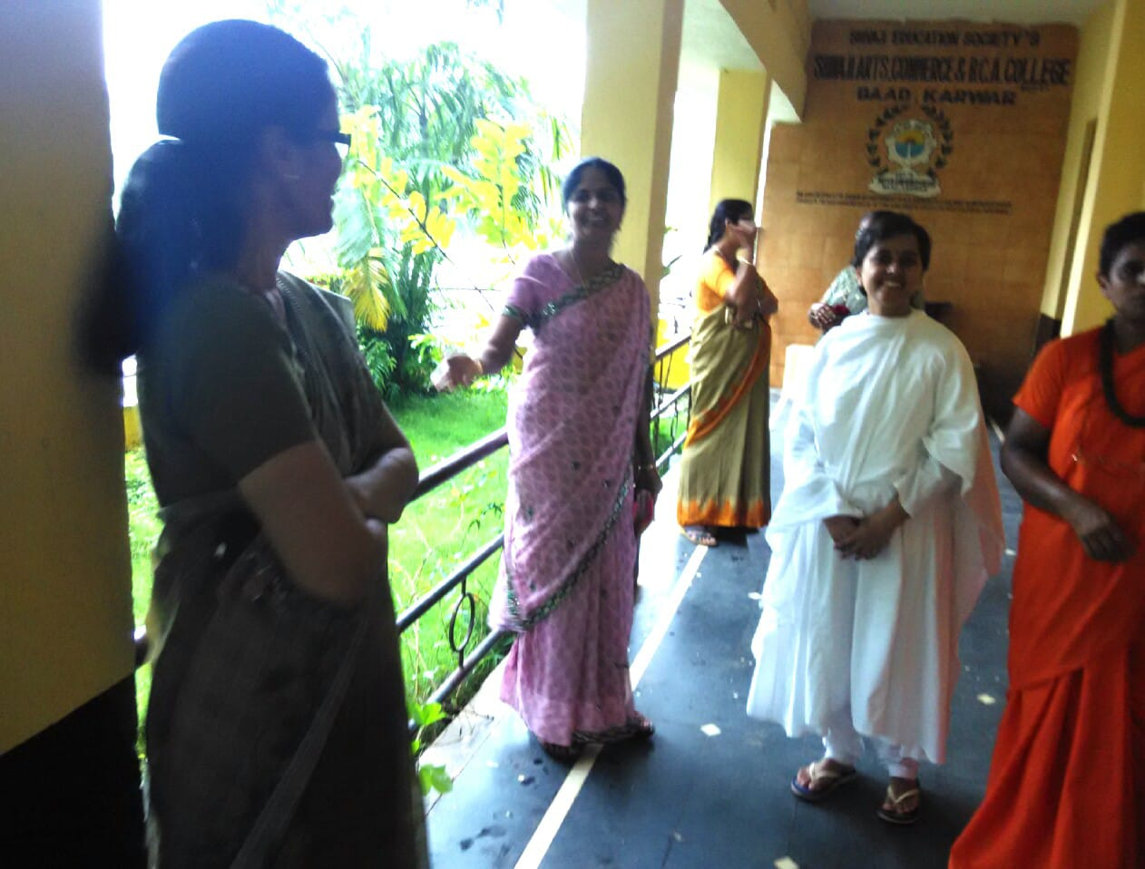

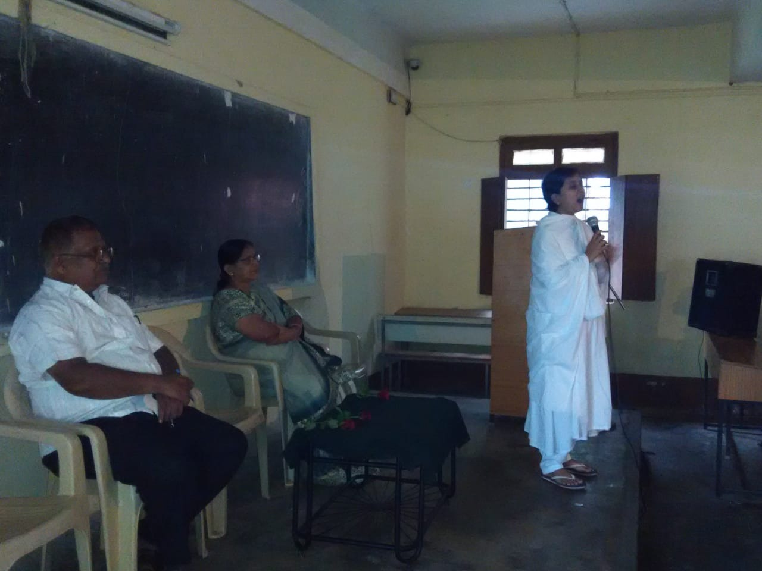

Report of Gender equity workshop

Ladies department of Shivaji college,Karwar conducted a legal awareness program on 7th September, 2018.Smt.Sandhya Talekar, a renowned district court lawyer, was the guest of honor.

Dr.A.M.Naik, Principal, Shivaji Arts and Commerce college, Baad,Karwar introduced and welcomed the guest to inaugurate the function. The lawyer enlightened the girls, how lucky they are to be born in this century, where they can enjoy their rights. She convinced the students gender equality is not about clearing the genders’ differences, but providing fundamental human rights and beneficiaries to all genders.

The function was attended by the lecturers, non-teaching staff and students. Prof.Sapna Naik ,chair person ladies department proposed vote of thanks.

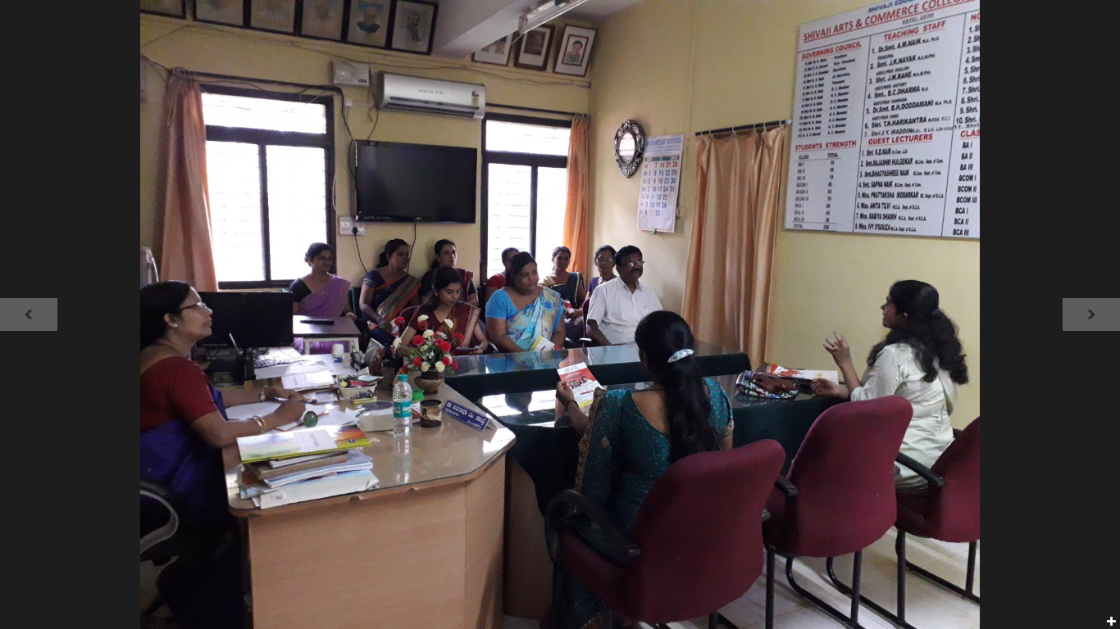

Report on student seminar, ‘World Population Day’

The IQAC and Department of Economics jointly conducted student seminar on World Population Day on 11th July 2018. The head of the Department of Economics*, Principal* A.G.Kerlekar was the resource person of the function. The program was attended by all the students of the college accompanied by the teaching staff.

The students were enthusiastic to present their papers. Nearly 25 papers were presented from the commerce and the arts programs. Inaugurating the seminar, the resource person informed the students that the world population day is observed every year on 11th July. He told the main purpose of observing this day is to draw attention towards the issues arising out of rising population across the globe .The resource person made efforts to enhance awareness of population issues including their relations to the environment and development.

The students presented their papers enthusiastically. Their papers showed their keen efforts in writing and presenting the papers, prepared by them. All the paper presenters were presented with a token of admiration by the college in the end of the program.

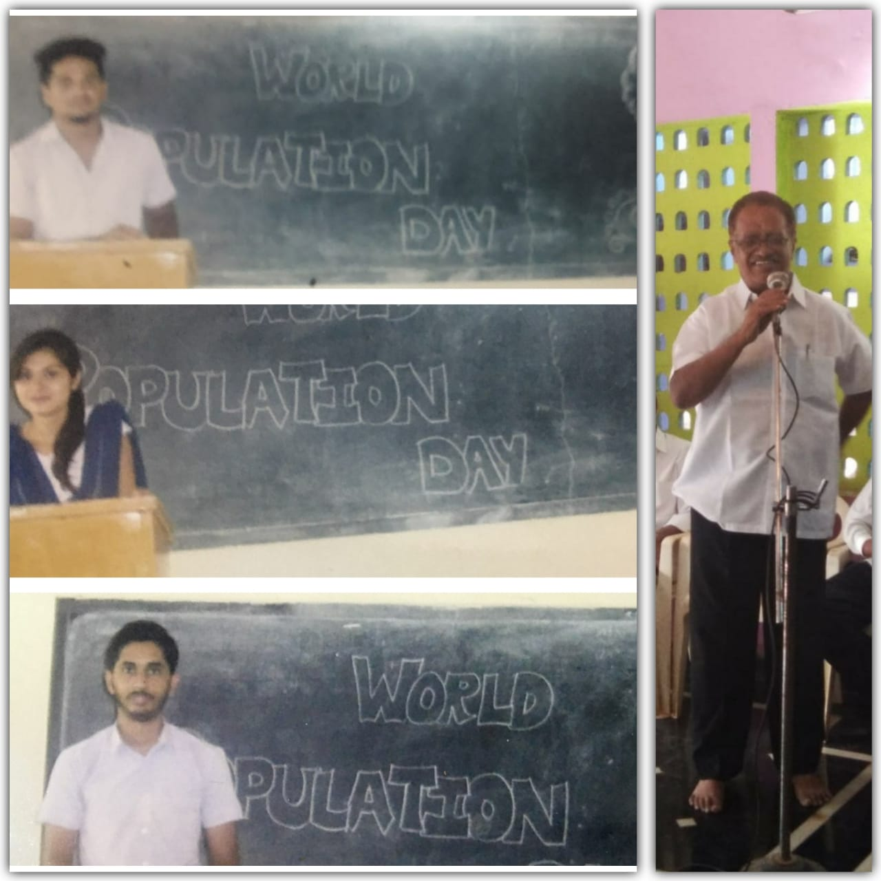

Report on meditation program

To motivate the young minds of the youths, the IQAC has arranged a motivational seminar in collaboration with Ramakrishnashrama,Karwar branch. The meditation program was conducted on 8th January 2018.

*Principal* A.G.Kerlekar *gave the welcome speech.* Thereafter, the resource person, Shri Santosh Guruji of Ramakrishnashrama, delivered his lecture in a lucid style.The guruji explained meditation has many benefits for students.The first and the foremost is, it lowers stress level. It also decreases exam tension, improves self esteem, gives health and happiness. So guruji convinced the students that they can rely upon meditation.

The function was attended by the lecturers, students, non-teaching staff. Prof. Bhagyashri compered the function. Prof.T.N. Harikantra presented vote of thanks.

Report on the workshop Introduction to yoga

To create awareness among the college students, the physical education department of the college and the Department of Yoga studies, Karnatak University, Dharwad jointly conducted yoga and meditation workshop on 9th August 2018.

During the workshop, the resource person, Dr M.S. Arer, assistant professor, Department of Yoga studies, Karnataka university, Dharwad inaugurated the workshop and an add-on course on yoga, of 30 days duration. The function was attended by nearly 80 participants out of which, 30 enrolled to the add- on course.

Speaking on the occasion, the resource person elaborately discussed the benefits of yoga to common man. He explained, how yoga helps in various ways. He told, it improves the physic, the life pattern, intelligence, eyesight, breath and whatnot. The yoga guru demonstrated some pranayama exercises to wind up the function.

The function was attended by the lecturers, students, non-teaching staff. The principal welcomed the guests. Prof.T.N. Harikantra presented vote of thanks.

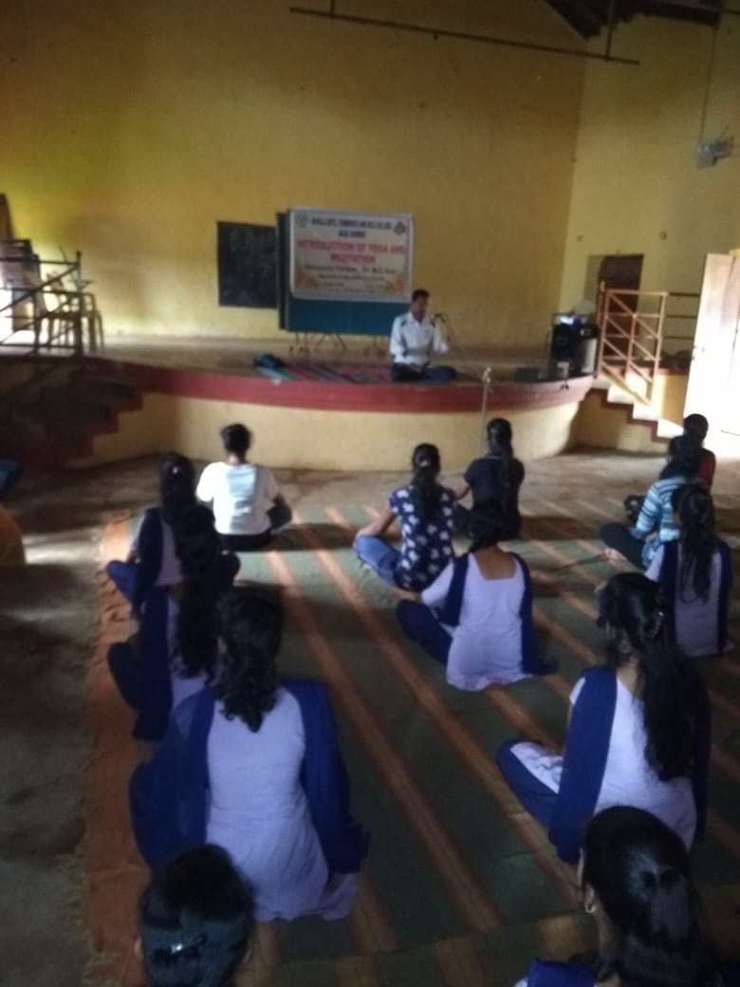

Report on Road Safety awareness program

Shivaji Arts and Commerce college in collaboration with Police department and RTO department ,Karwar conducted an awareness program on13th August 2018. Omprakash, CPI and Ravi Bisralli,RTO were the guests of honor. Dr.A.M.Naik, Principal, Shivaji Arts and Commerce college,Baad,Karwar introduced and welcomed the guests to inaugurate the function.

While addressing the students, Mr. Omprakash stressed on the importance of physical well being . He gave lecture on discipline and obedience to law.

Speaking on the occasion, Mr. Ravi Bisralli,RTO Karwar enlightened the students about traffic rules. He informed ,how traffic rules help to avoid accidents and save the valuable life.

The function was attended by the lecturers, students, non-teaching staff, management members. Prof. Bhagyashri compered the function. Prof.T.N. Harikantra presented vote of thanks.

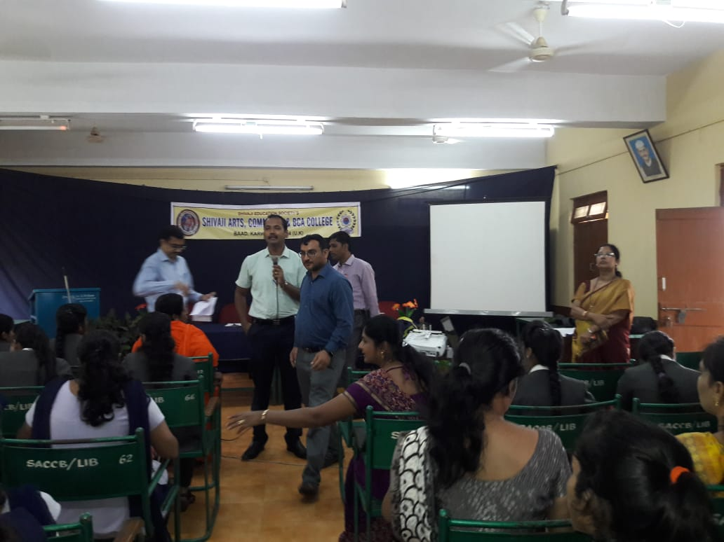

Report on transformation of India through digital practice

On 20th December 2018, to spread the knowledge of the importance of computer knowledge for transformation of india an awareness program conducted by the department of computer application.

Prof.Sarvesh Naik explained transformation of India can only happen through digital practice.He tried to convince the audience the knowledge of computer is a must in this century. He said literacy means computer literacy. One who does not know operation of computer will have to face the dire consequences. He suggested to the audience to become computer literates without much delay.

The function was attended by the lecturers, students, non-teaching staff, management members. Prof. Bhagyashri compered the function. Prof.T.N. Harikantra presented vote of thanks.

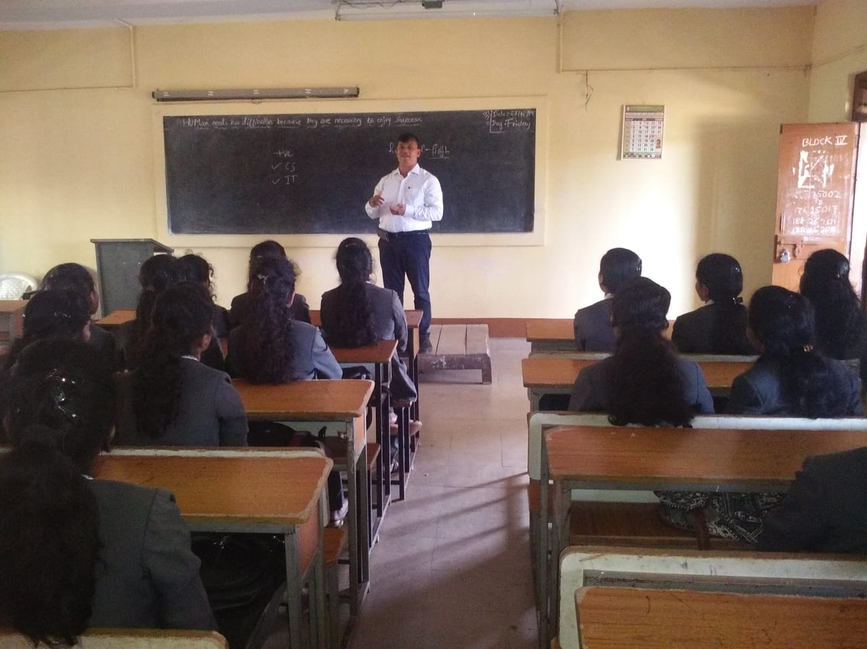

Report on Voters day program

To create awareness among the young students ,about the significance of voting, the union department of the college arranged a workshop on voters Day on 25th January 2019.

Dr. Anuradha Naik, HOD of political science was invited as the resource person for the function. The resource person speaking about the significance of voting, explained, how the young voters are encouraged to take part in political process by observing 25th January as national voters Day, since 2011, to mark the commissions foundation day Prof. J.M.Rane welcomed the resource person. Dr.Dodamani proposed vote of thanks.The function was attended by the teaching and non-teaching faculty of the college, some of the management members, alumni and the students.

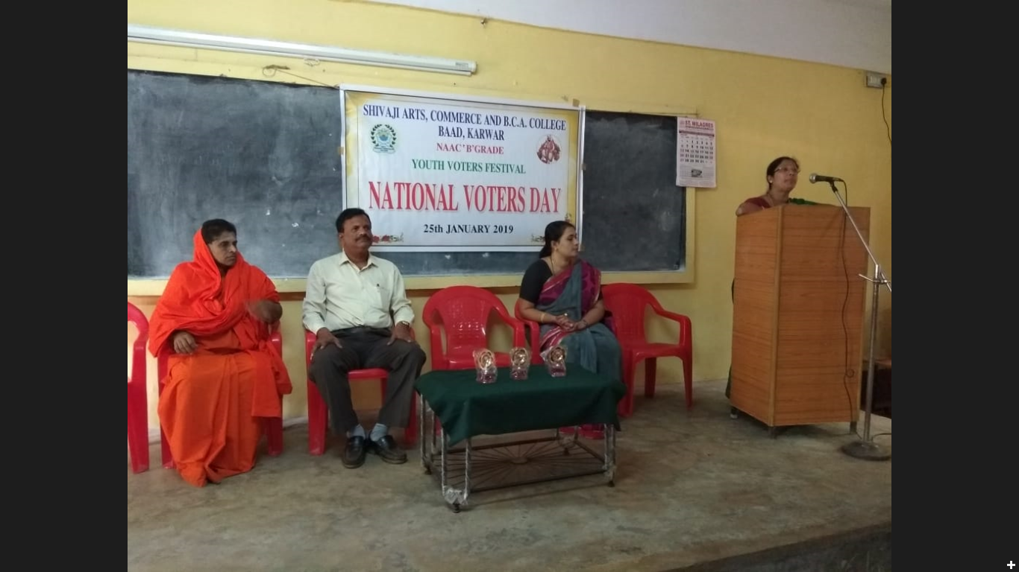

Workshop on career guidance

The career counseling and guidance cell arranged a workshop, to assist students to do better career choices. Shivaji college has signed a MOU with Pragati Poshak,Dharwad. The institute Pragati Poshak,Dharwad conducted a workshop on 4/2/2019. The program was specially arranged for final year students.

Dr.Anuradha Naik,Principal,delivered the welcome address. Thereafter the team leader, Mithun Joshi, the faculty of Pragati Poshak,Dharwad, gave many tips regarding career guidance and placement. Prof.T.N. Harikantra,the placement officer presented vote of thanks.

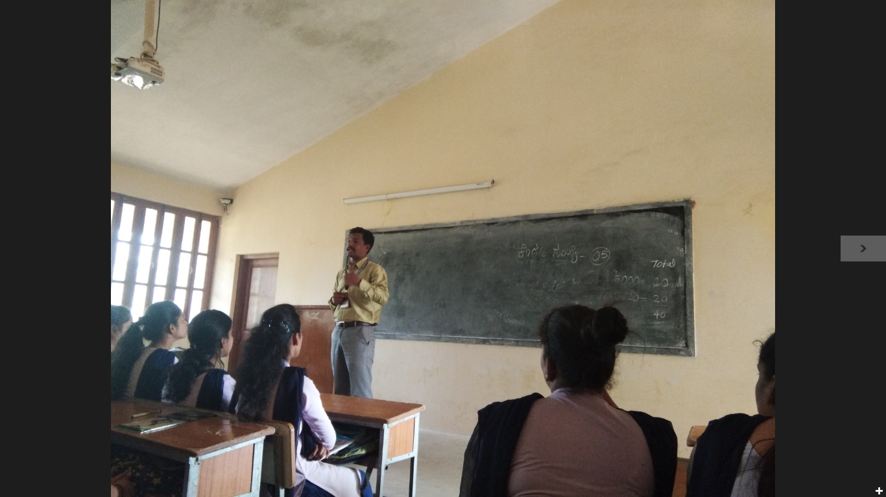

17-18.

Report on youth week program

To commemorate the birth anniversary of Swami Vivekananda, the IQAC has decided to observe youth week program from 12th January to 19th January 2018. The week-long program of youth week celebration was inaugurated by Dr. Giri, department of Sanskrit, GFGC, Karwar.

Speaking on the occasion, organised to mark the birth anniversary of Swamiji , as youth week, the chief guest emphasized that character building ,which is one of two Indian philosophers teaching was based on all inclusive and uniform value system and questioned if any commitment towards the nation and the constitution could be calculated in the young generation without community of values. The professor advised the students like Swamy, to take up one idea. Advised to make that idea their life, asked them to think of it, live on that idea let the brain ,the body, muscles, nerves ,every part of their body be full of that idea and advised to leave every other idea. He concluded that the spiritual giants are produced in this way. So he advised the students to succeed in the same way.

Prof.A.G.Kerlekar, principal welcomed the guests. The function was attended by the heads of all the sister institutions, lecturers, non-teaching faculty and students . Prof.A.S.Rane proposed vote of thanks.

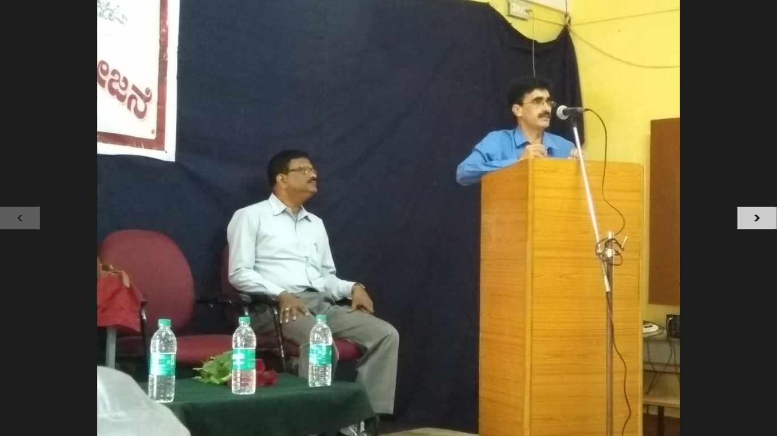

Report on State level seminar on rights of women

To enlighten the girls about the rights,they are constitutionally empowered with, the ladies department of the college organized ‘Rights of women’, a state-level seminar on 16th January 2018. Mrs Sandya Talekar, a renowned district court lawyer, was invited as the resource person for the seminar. The chief guest of the occasion explained , how the concept of gender sensitivity is a way to reduce the barriers caused due to the discrimination. While addressing the students, she threw light on the eleven exclusive rights for women .1.Women have right to equal pay .2. Right to dignity and decency .3.Right against workplace harassment. 4.Right against domestic violence .5.Right to keep their identity anonymous, if they are sexual assault victims.6.Right to get free legal aid.7.Right not to be arrested at night.8.Right to register virtual complaints. 9.Right against indecent representation. 10 .Right against being stalked. 11.Right to zero FIR.

Dr.A.M.Naik, principal welcomed the guests. The function was attended by the lecturers, non-teaching staff and students. Dr.A.M.Naik,chair person ladies department proposed vote of thanks.

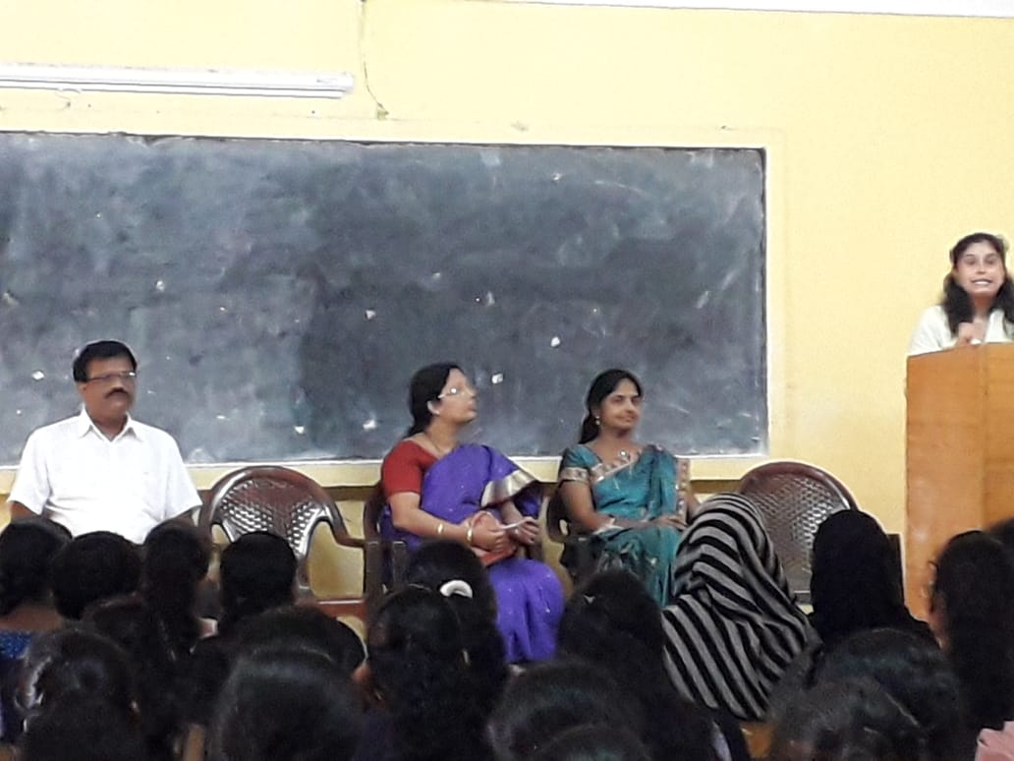

Report on Voters day program

To create awareness among the young students ,about the significance of voting, the union department of the college arranged a workshop on voters Day on 25th January 2018.

Dr. Anuradha Naik, HOD of political science was invited as the resource person for the function. The resource person speaking about the significance of voting, explained, how the young voters are encouraged to take part in political process by observing 25th January as national voters Day, since 2011, to mark the commissions foundation day. The resource person explained how the country is doing vigorous exercise to identify all the eligible voters, attaining the age of 18 years as on January 1 every year, in each of the 8,500,00 polling stations across the country .

Principal A.G.Kerlekar welcomed the resource person. Dr.Dodamani proposed vote of thanks.The function was attended by the teaching and non-teaching faculty of the college, some of the management members, alumni and the students. 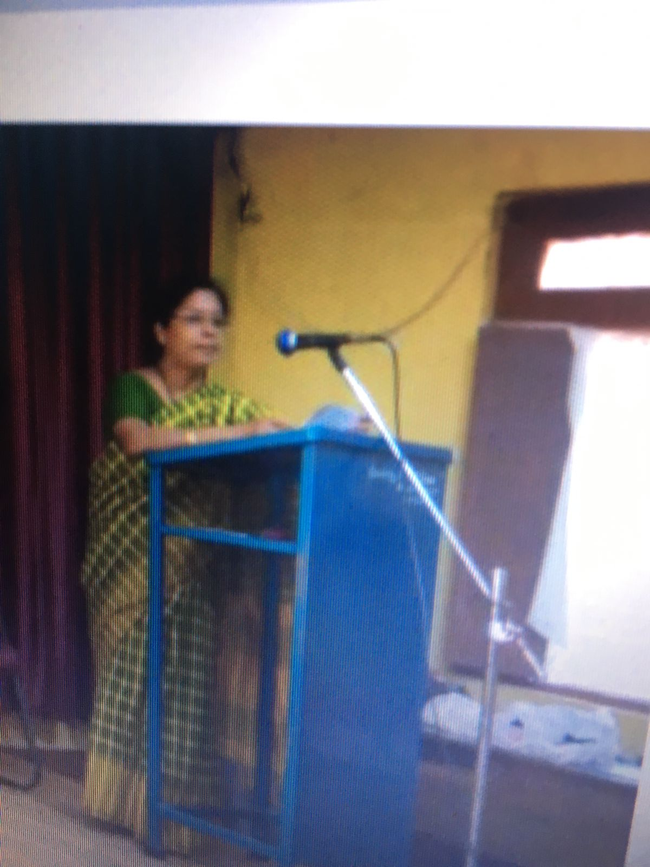

Report on awareness workshop on prevention of AIDS/HIV

*The college red ribbon wing and NSS unit jointly conducted AIDS awareness workshop, to create awareness among the students on 20th February, 2018, in association with Karnataka AIDS preventive society, Karwar.*

*Principal A.G. Kerlekar gave the welcome speech. Thereafter, Siri Srikanth Hiremath of Karnataka AIDS preventive society delivered a lecture among the students and made them aware on HIV/ AIDS issues and also shared its objectives and strengthening of red ribbon wing unit through a PowerPoint presentation .After the lecture students took part in an interaction and cleared their misconception. The queries were answered by the speaker.*

*The function was attended by nearly 150 students, staff and members of the education society. The function began with the invocation song sung by Miss Apoorva and party. Prof.J.M.Rane proposed vote of thanks.*

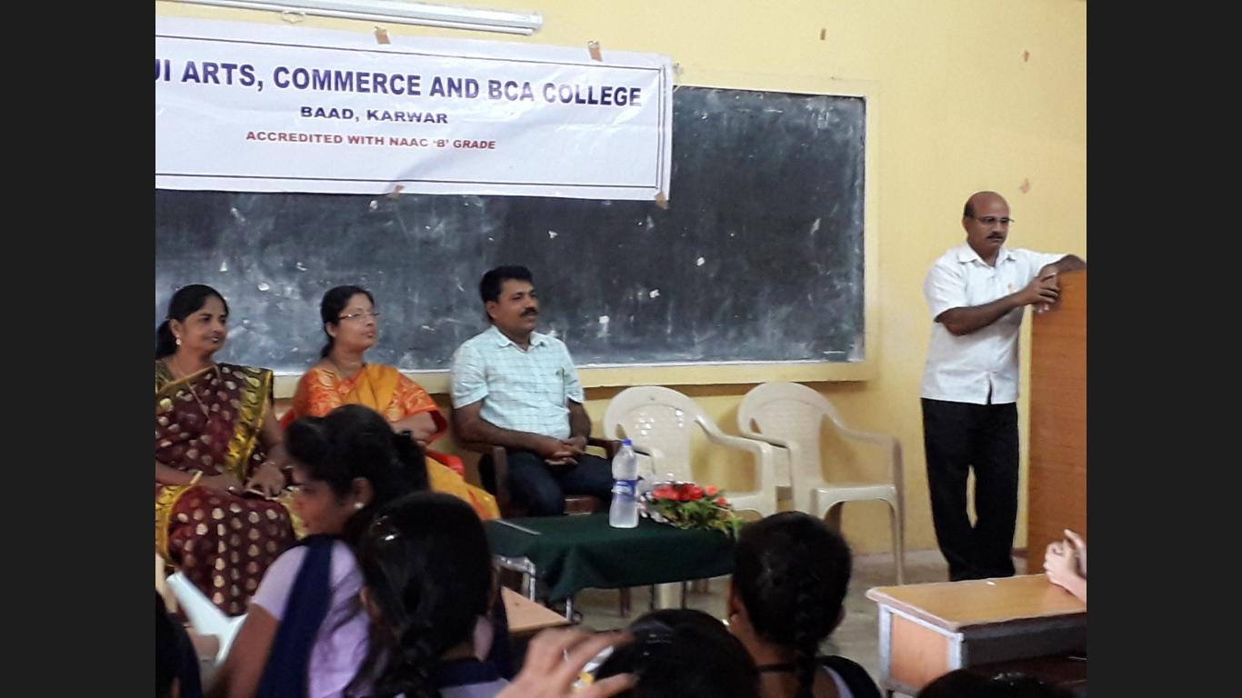

Report on Blood group identification & donation awareness workshop

The college red ribbon wing and NSS unit jointly conducted the blood group identification & donation awareness workshop, to create awareness among the students on 3rd June,2018, in association with Azad Youth club ,Karwar and government hospital Karwar.

Principal A.G.Kerlekar welcomed the resource person. Mr.Nazir Shaikh, the president of Azad Youth club ,Karwar, said every year, World Blood Donor Day is observed on June 14 to raise awareness about the need to donate blood regularly to increase the availability of safe blood and its products for patients in need. This day is also an occasion to thank donors who volunteer to donate the life-saving gift of blood. Volunteer blood donation is a safe and simple procedure that involves a donor giving one of the following blood products: whole blood, red blood cells, plasma, or platelets which is useful to save peoples life in dire situations

The laboratory assistants conducted the blood group identification work and let the students know their blood groups. Even few students voluntarily donated blood.

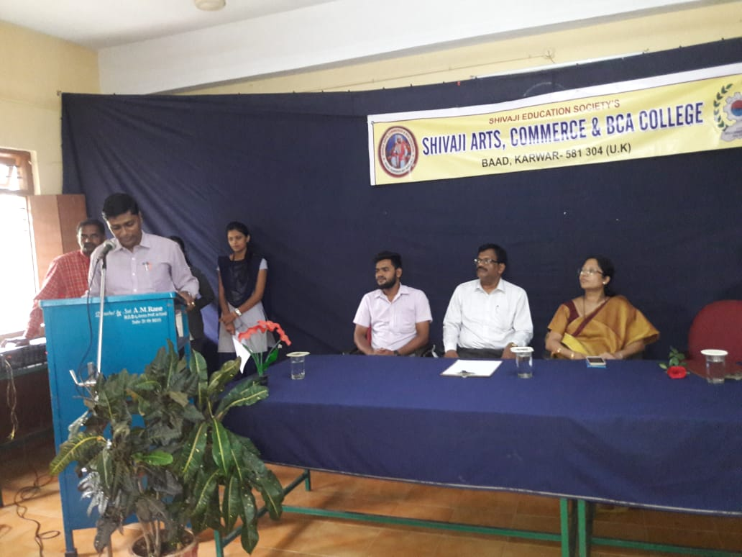

World women’s Day

To ensure the girls and women, who are working in the institution, about their equal status in the society, the ladies department of the college organizes ‘World women’s Day ’, every year on 8th March. Likewise the occasion was celebrated on 8th March, 2018, with Dr.Savita K.S.,HOD Surgery, Govt. Medical College,Karwar.

*Principal A.G. Kerlekar gave the welcome speech. Thereafter,*

the doctor explained, why on 8th March world women’s day is celebrated .She said, it is strongly linked to the woman’s movement during the Russian revolution of 1917. The day is celebrated to celebrate the historical cultural and political achievements of women, the day is also observed in support of taking action against gender inequality around the world to raise awareness about women’s inequality. Dr Savita advised the women, regardless of the rigorous daily demands, the women need to take care of herself. The doctor suggested the woman to see a doctor at least once a year, to ensure that she is up-to-date with her health care needs.

The function was attended by the lecturers, non-teaching staff and students. Dr.A.M.Naik,chair person ladies department proposed vote of thanks.

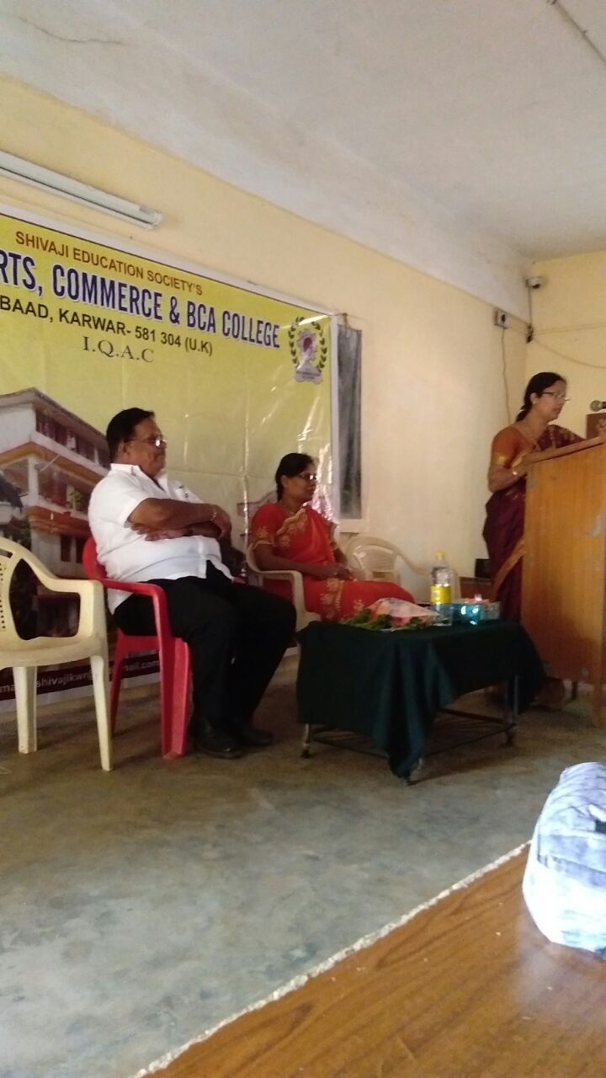

16-17

Environmental awareness program

On 10th June2016,the union department conducted Go green program, in association with Forest dept.& State Bank of Mysore. To create environmental awareness among the young students new saplings were planted in the college campus.

Mr.savant,the forest officer explained to get good rain, proportionate number plants are necessary.

The function was attended by the lecturers, non-teaching staff and students. Prof.A.S.Rane proposed vote of thanks.

.

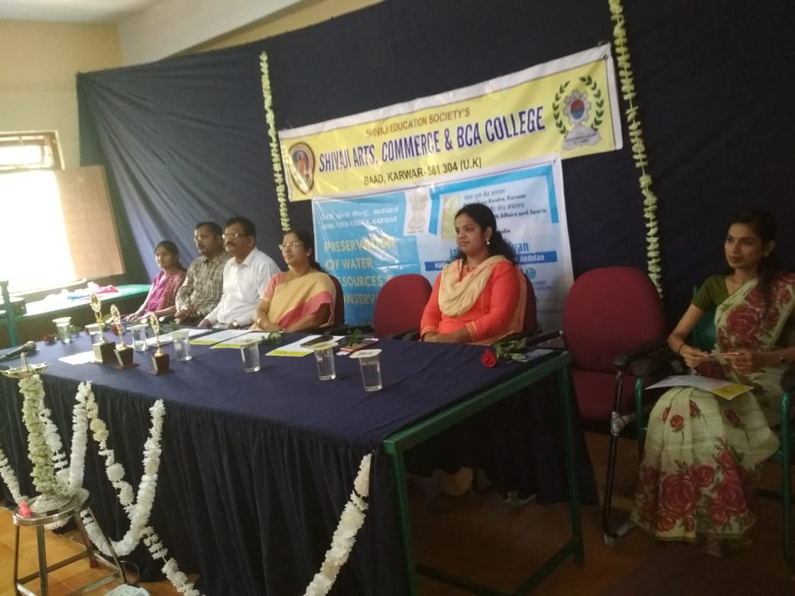

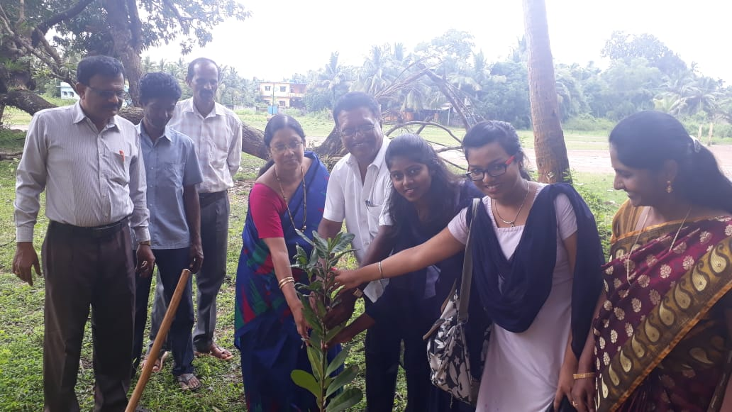

Career guidance program

The career guidance cell arranged a workshop, to assist students to do better career choices. On 8th August2016, Career guidance cell in association with Foremost Information& Data Exchange, ltd.,Panjim,Gao conducted a workshop for B.Com students on Computer accountant as career. Principal *A.G. Kerlekar*, delivered the welcome address. Thereafter the team leader, Preetam Rane, the faculty of , Foremost Information& Data Exchange, ltd.,Panjim,Gao gave many tips regarding Computer accountant as career. Prof.AS.Rane,the placement officer presented vote of thanks.

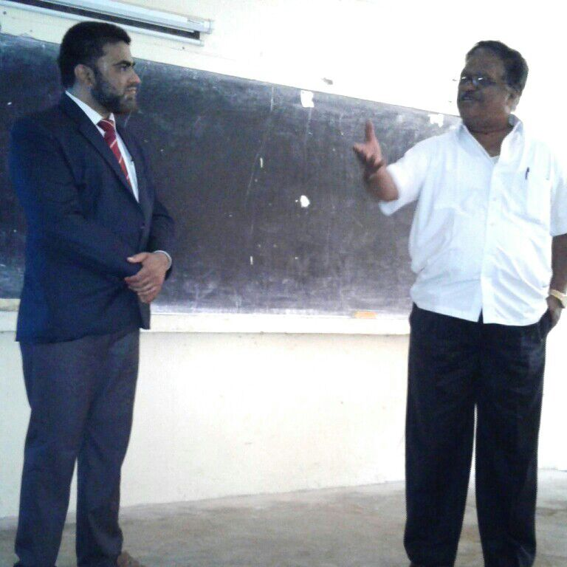

Report on ‘Time management and banking’

The department of commerce in association with Bank of India conducted an awareness program on ‘Time management and banking ’ on 8th December 2016. Mr.Durgesh S.Phal,Manager addressed the students.

Addressing the students he stressed on the importance of time management for the students. He advised the students to take life bit seriously, so that they can pursue their long term goals of life. Speaking on the occasion, he guided students to give-up, let go attitude and to concentrate on their goals. He added, with willing efforts they have the power to achieve miracles. Prof.AS.Rane,the placement officer presented vote of thanks.

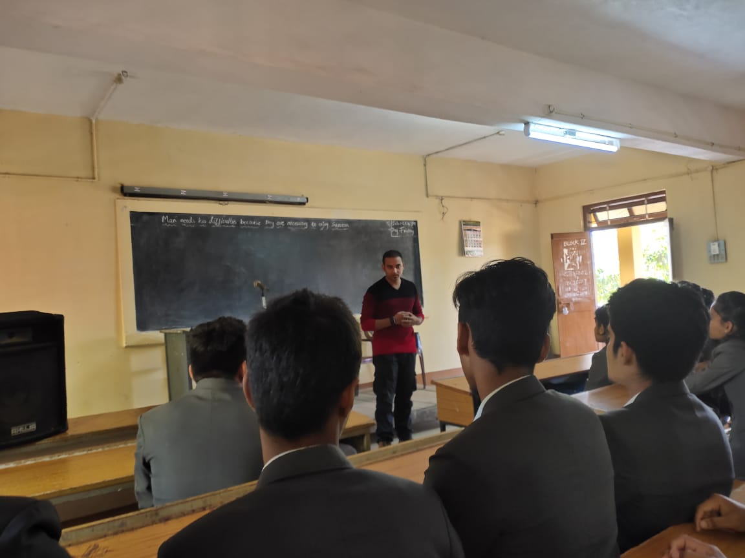

Kannada literary program

The department of Kannada in association with Kannada literary association ,Karwar branch conducted the Kannada literary program on 18th August 2016.

Shri Vishnu Naik,the president of Kannada literary association ,Karwar branch was the chief guest of the event. Speaking on the occasion , the chief guest stressed upon our genuine efforts to make it sure, that the residents of Karnataka have to initiate some steps for the survival of the language. During the program the participants presented papers and articles.

World tourism day

The department of Economics conducted World tourism day on

27/9/2016,in association with Premier group of hotels ,Karwar.

Speaking on the occasion the proprietor Mr.Maruti Rane threw light on the employment opportunity in hotel industry.

He said there is too much scope in hotel industry in Karwar, as this place is known for its natural beauty, because of its beaches.He even recalled,how the great poet ,Rabindranath Tagore was inspired by the beauty of Karwar and called it Kashmir of Karnataka. Prof.A.S.Rane,the placement officer presented vote of thanks.



Workshop on health awareness-an extension activity

On 28th September 2016,college NSS unit conducted a health awareness workshop in the adopted village Wajantriwada,in association with Canara bank,Nandangadda,Karwar.Conducting the extension activity both the NSS officer and the bank manager opined that health is important than anything else in life.The function witnessed the noble cause jointly conducted by both the institutions i.e the distribution of free health cards of Father Mulla hospital,Mangalore.

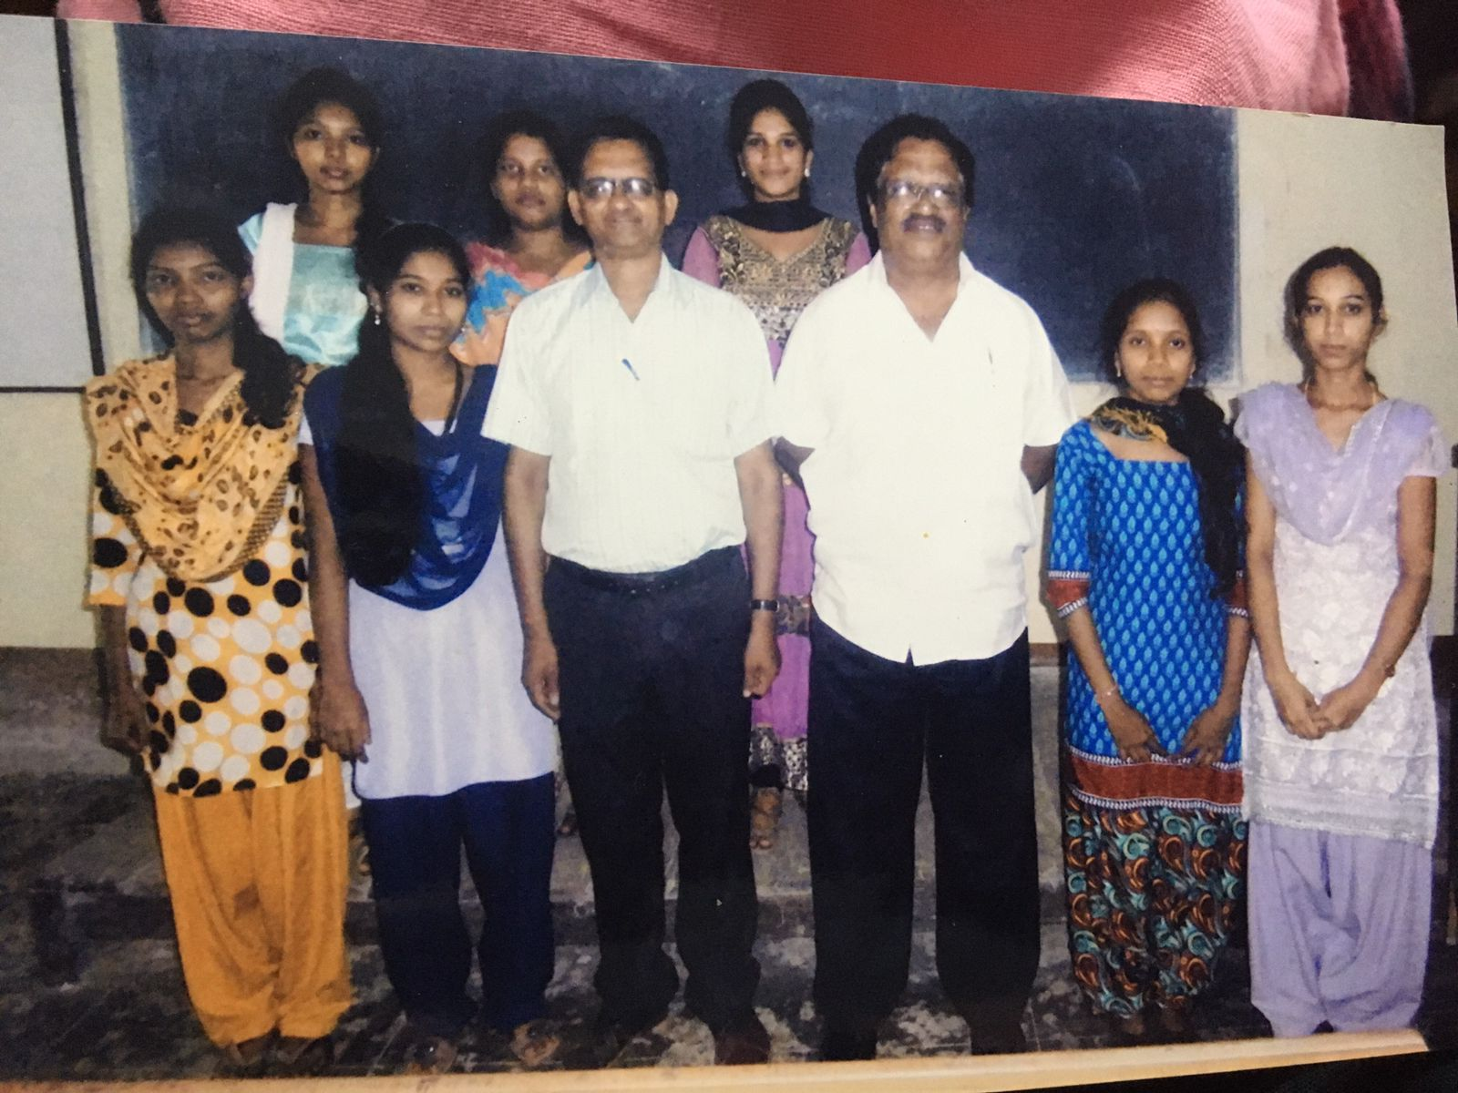

Seminar on Mind and Memory management

A one day Seminar on’ Mind and Memory management’ was conducted by student welfare department, keeping in view, the wellbeing of the mind of the students invited a psychiatrist, Dr.Girish of Kasturaba medical college,Manipal on 4th October 2016.

Addressing the students, the doctor stressed on the importance of mind and memory management for the students. He advised the students to take life bit seriously, so that they can pursue their long term goals of life. Speaking on the occasion, he guided students to give-up, let go attitude and to concentrate on their goals. He added, the wellbeing of the mind is very essential for memory management. Prof.A.S.Rane,the placement officer presented vote of thanks.

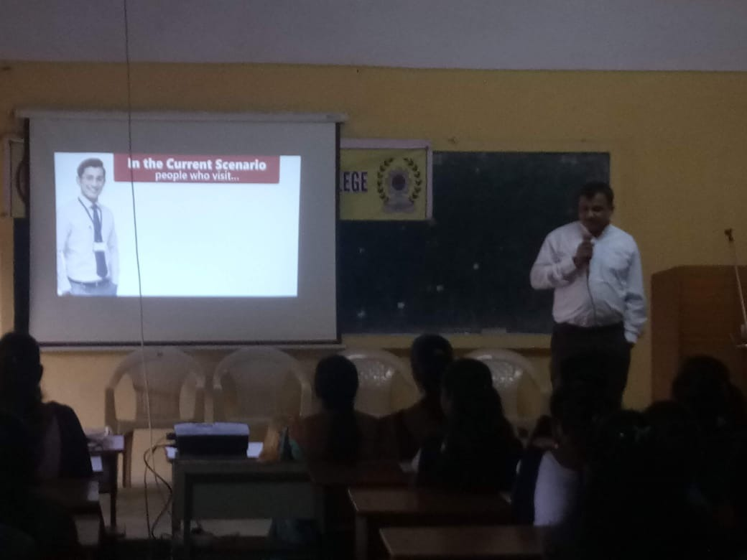

Workshop on Road safety awareness program

Shivaji Arts and Commerce college in collaboration with Police department and RTO department ,Karwar conducted an awareness program on 14th January 2017.Shri Divakar Naik, CPI and Manoj Patil,RTO were the guests of honor. Dr.P.P.Anvekar , Principal, Shivaji Arts and Commerce college,Baad,Karwar introduced and welcomed the guests to inaugurate the function.

While addressing the students, Mr. Divakar Naik stressed on the importance of physical well being . He gave lecture on discipline and obedience to law.

Speaking on the occasion, Mr. Manoj Patil ,RTO Karwar enlightened the students about traffic rules. He informed ,how traffic rules help to avoid accidents and save the valuable life.

The function was attended by the lecturers, students, non-teaching staff members.

Prof.A.S.Rane,the placement officer presented vote of thanks.

Management opportunities

The department of commerce in association with Surana college of management conducted an awareness program on 26th February 2017.The function was arranged keeping in view of the curricular prospects of the final year students.

Addressing the students the faculty of Surana college stressed upon the importance tips regarding progression to higher studies. They gave couselling sessions to all the final year students ,who have attended their workshop. Prof.AS.Rane,the placement officer presented vote of thanks.